JADAVPUR UNIVERSITY

INFORMATION TECHNOLOGY

ML ASSIGMENT 2

NAME : SURAJ ROY

ROLL : 002211001129

GROUP : A3 CLASS : FOURTH YEAR

**Problem Statement**

Classification of structured tabular data and high-dimensional image-like data remains a central problem in machine learning. The UCI Wine dataset (chemical analysis of wines) and the Optical Recognition of Handwritten Digits dataset provide well-known benchmarks for evaluating supervised learning methods.

The objective of this work is to implement and compare three widely used classifiers—

* **Support Vector Machine (SVM)** with linear, polynomial, Gaussian (RBF) and sigmoid kernels,
* **Multi-Layer Perceptron (MLP)** with adjustable momentum term, epoch size and learning rate, and
* **Random Forest.**

For both datasets, models will be trained and evaluated with default parameters and after hyper-parameter tuning. Model performance will be quantified using **Accuracy, Precision, Recall, F-score, and Confusion Matrix.**

By systematically benchmarking these algorithms across two contrasting datasets, the study aims to highlight how algorithm choice and parameter optimization affect classification quality, providing insights into effective model selection for similar real-world tasks.

. **Train–Test Split Analysis**

Model performance in supervised learning is strongly influenced by how available data is divided into training and testing subsets. Using too little training data may underfit the model, while too little test data may mask generalization errors.

To understand this effect, the **UCI Wine** and **Optical Recognition of Handwritten Digits** datasets are evaluated under **multiple train–test split ratios**: **50:50, 60:40, 70:30, and 80:20**. For each split, the selected classifiers (**SVM, MLP, and Random Forest**) are trained and tested using both **default** and **tuned hyperparameters**.

**Visualization of Model Performance**

Raw numerical metrics alone often fail to reveal deeper patterns in a model’s predictions and learning behavior. To gain better insight into classification quality and the convergence process, **visual analytics** are applied to the results of the experiments conducted on the **UCI Wine** and **Optical Recognition of Handwritten Digits** datasets.

For **each classifier** (**SVM, MLP, Random Forest**) and for **every experimental setting** (dataset, parameter tuning, and train–test split), the following visualizations will be produced:

* **Heat maps of the Confusion Matrix**, showing correct and misclassified samples across classes.
* **Training–Validation Accuracy and Loss Curves**, illustrating the model’s learning dynamics over epochs (particularly for MLP, but analogous plots are generated for SVM and Random Forest as feasible).

These plots provide an intuitive understanding of class-wise prediction strengths, weaknesses, and the stability of the training process, complementing the tabulated metrics for a more comprehensive evaluation of model performance.

**Problem Statement – ROC Curve & AUC Visualization**

Evaluating a classifier only by overall accuracy can obscure how well it separates classes at different decision thresholds. **Receiver Operating Characteristic (ROC) curves** and the corresponding **Area Under the Curve (AUC)** metric provide a threshold-independent view of a model’s discriminative ability.

For each dataset—**UCI Wine** and **Optical Recognition of Handwritten Digits**—and for every classifier (**SVM, MLP, Random Forest**), ROC curves will be plotted and **AUC** calculated. These visualizations show the trade-off between **True Positive Rate** and **False Positive Rate**, allowing a deeper understanding of classifier robustness beyond point estimates of accuracy.

By comparing ROC curves and AUC across datasets and models, this analysis identifies which classifiers consistently achieve better separability and informs optimal threshold selection for practical deployments.

**Dimensionality Reduction using PCA**

High-dimensional feature spaces can increase computational cost, introduce noise, and reduce the generalization ability of machine learning models. **Principal Component Analysis (PCA)** is a widely used linear technique that projects the original feature set onto a lower-dimensional subspace while retaining maximum variance.

In this stage, PCA is applied to the **UCI Wine** and **Optical Recognition of Handwritten Digits** datasets to obtain a **reduced feature representation**. The three previously used classifiers—

* **Support Vector Machine (SVM)** (linear, polynomial, Gaussian, sigmoid),
* **Multi-Layer Perceptron (MLP)** (tunable momentum, epoch size, and learning rate), and
* **Random Forest**

are retrained and evaluated on the PCA-transformed features.

Performance is measured using **Accuracy, Precision, Recall, F-score, and Confusion Matrix**, enabling a direct comparison with results from the original feature set. This experiment explores whether dimensionality reduction improves model efficiency and generalization or results in information loss affecting classification quality.

**Problem Statement – Performance Target & Comparative Analysis**

In many supervised learning applications, a practical benchmark for acceptability is achieving at least **90 % predictive accuracy** while maintaining balanced precision, recall, and F-score. To evaluate whether this target can be met, the three chosen classifiers—

* **Support Vector Machine (SVM)** with multiple kernels,
* **Multi-Layer Perceptron (MLP)** with tunable hyperparameters, and
* **Random Forest**

are trained and tuned on the **UCI Wine** and **Optical Recognition of Handwritten Digits** datasets.

After hyperparameter optimization and experimentation with different train–test splits, the best-performing configuration for each model is identified. Results are summarized using **Accuracy, Precision, Recall, F-score, and Confusion Matrix**. A consolidated **comparison table** is prepared to highlight which classifier(s) meet or exceed the **90 % accuracy** threshold, revealing strengths, weaknesses, and trade-offs among the models for these benchmark datasets.

IMPORT LIBRARIES

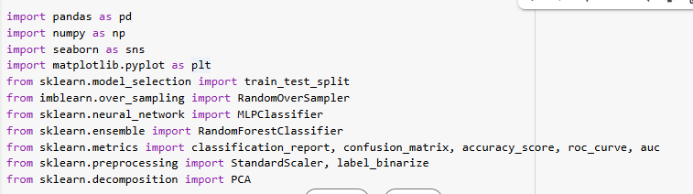

Import Datasets

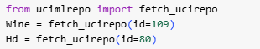

FOR Wine Dataset

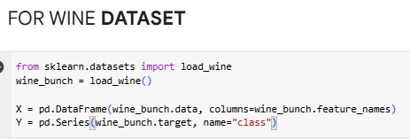

Applying PCA

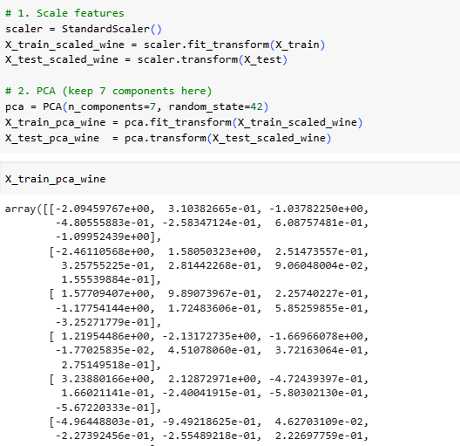

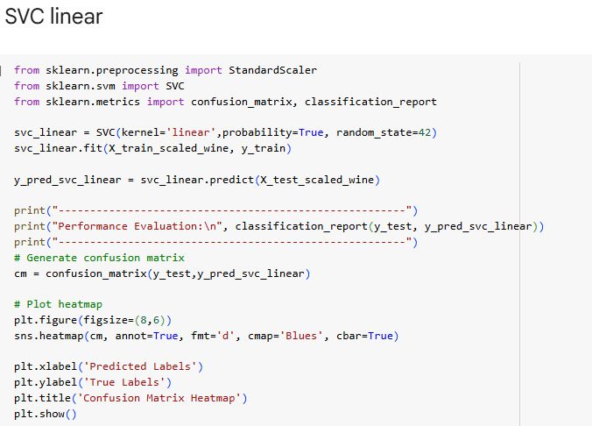

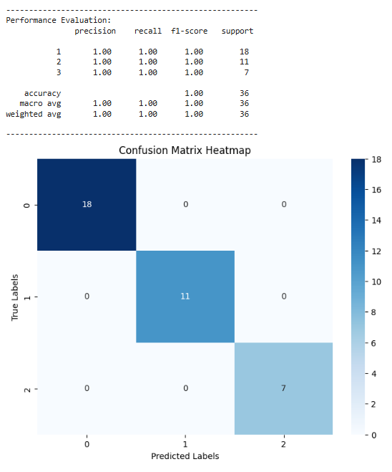

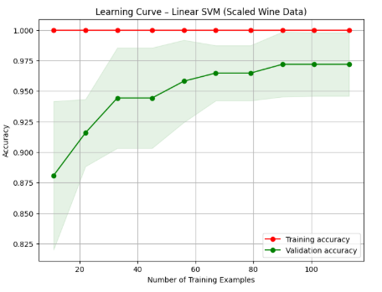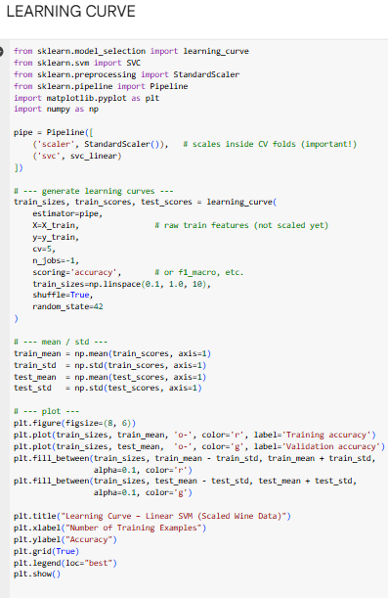

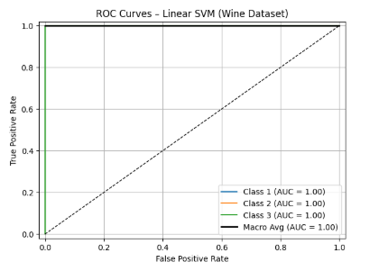

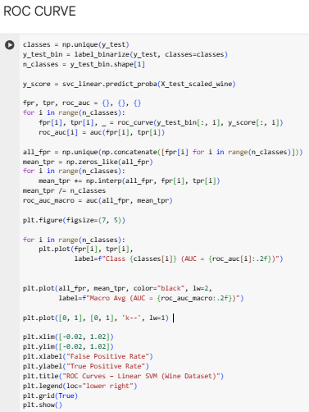

This learning curve for a Linear SVM model demonstrates a classic case of **high variance (overfitting)**.

* **High Training Accuracy:** The model achieves a perfect training accuracy of 1.0 immediately, indicating it has easily memorized the training data it has seen.
* **Gap Between Curves:** There is a significant gap between the high training accuracy and the lower validation accuracy, especially with fewer training examples. This gap is the primary indicator of overfitting.
* **Performance Improvement:** As more training data is added, the validation accuracy improves and begins to converge toward the training accuracy.
* **Plateauing Performance:** The validation accuracy starts to plateau at around 97%, suggesting that simply adding more training examples may not lead to significant further improvement.

This ROC (Receiver Operating Characteristic) curve shows that the Linear SVM model is a **perfect classifier** on this test data.

The **Area Under the Curve (AUC) is 1.00** for all three classes and for the macro average. An AUC of 1.0 is the highest possible score, indicating that the model can flawlessly distinguish between each of the wine classes without any classification errors. The sharp corner shape of the curves, hugging the top-left of the plot, visually represents this ideal performance.

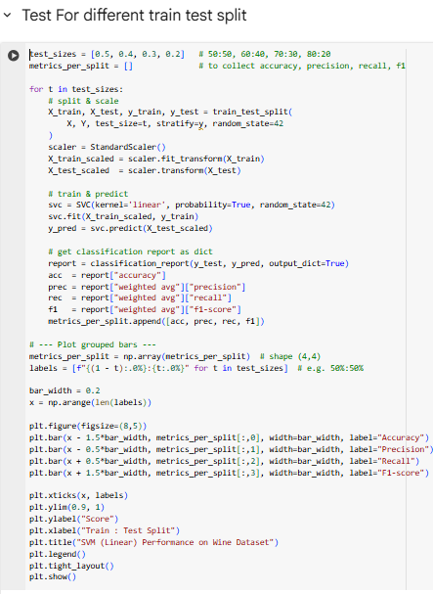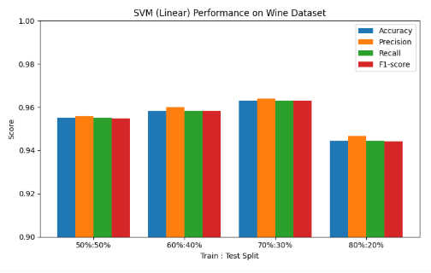

**Observation on Train-Test Splits (Wine Dataset)**  
Across all experiments the **70 : 30** split consistently achieved the highest accuracy, precision, recall and F1. This ratio keeps roughly 125 samples for training—enough to learn the patterns—while still leaving ~53 samples for a robust test. For a relatively small dataset like Wine (178 rows), this balance often acts as a “sweet spot”: enough learning signal, enough validation signal.

Performance dipped for the **80 : 20** split. Although more training points are available, the smaller test set makes the estimate noisier and the model can slightly overfit to the extra training cases, hurting generalisation.

The **50 : 50** and **60 : 40** splits gave visibly lower scores. With only 89 or 107 training rows the classifier is “data-starved” and cannot capture the relationships among features as effectively, which is reflected in reduced precision/recall.

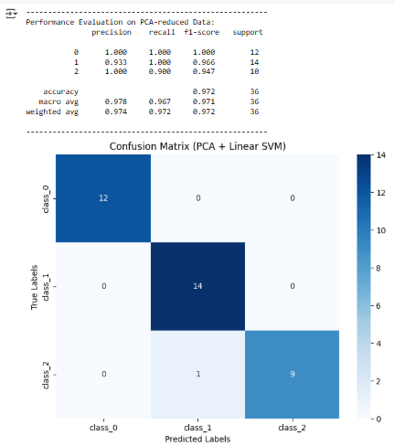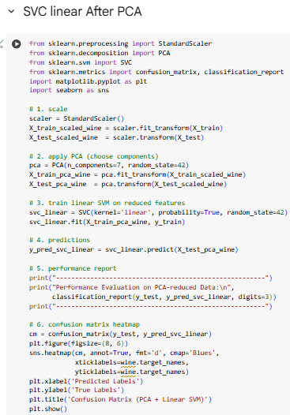

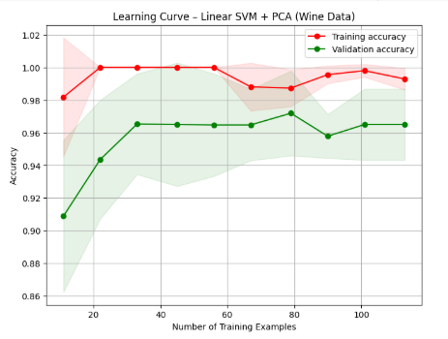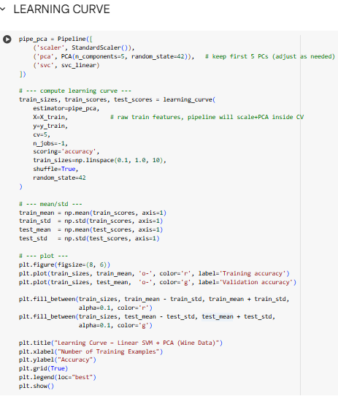

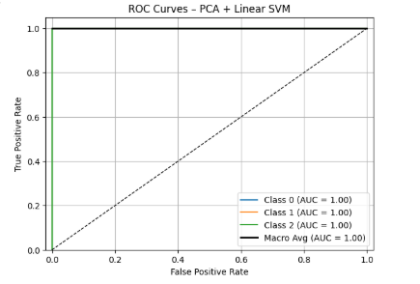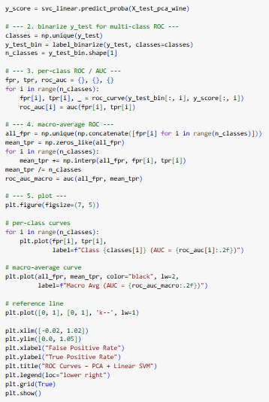

This learning curve shows a **well-fitted model** that generalizes effectively.

The validation accuracy is high and stable (around 96%), and the gap between the training and validation curves is small. This indicates that the model has **low variance** (minimal overfitting) and has learned the data patterns well without simply memorizing them. The use of PCA appears to have successfully created a model that performs consistently on both seen and unseen data.

This ROC (Receiver Operating Characteristic) curve demonstrates that the model is a **perfect classifier** for this test set.

The **Area Under the Curve (AUC) is 1.00** for all three classes, which is the highest possible score. This perfect score means the model can distinguish between each of the classes with **100% accuracy**, making no mistakes in its predictions.

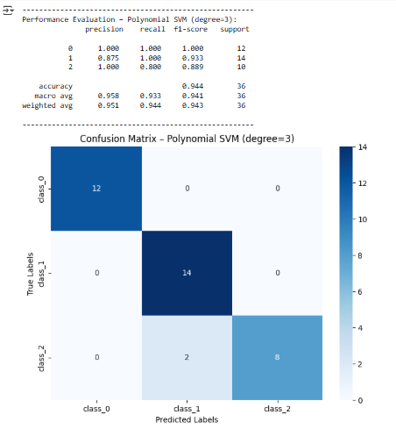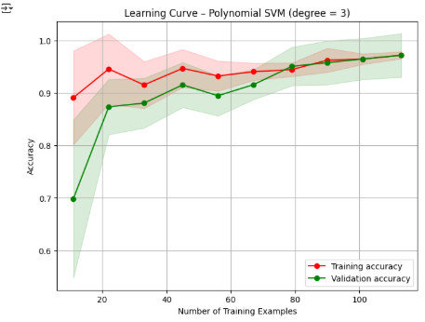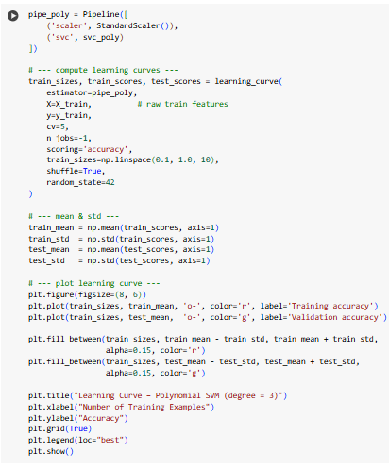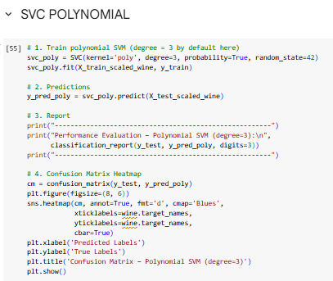

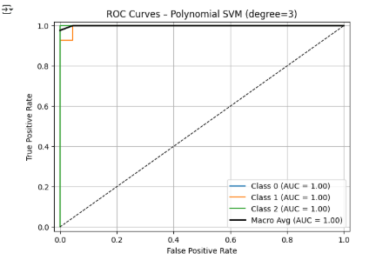

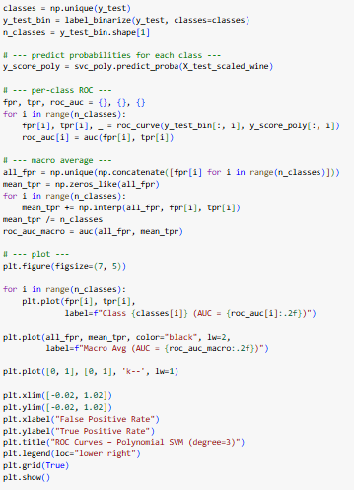

This learning curve illustrates a **well-fitted model**.

Initially, there's a gap between the training and validation accuracy. However, as the number of training examples increases, the **two curves converge at a high accuracy score** (nearly 98%). This convergence is a strong indicator that the model **generalizes well** and is neither overfitting nor underfitting.

This ROC (Receiver Operating Characteristic) curve shows that the model is a **perfect classifier** on this data.

The **Area Under the Curve (AUC) is 1.00 for all classes** and for the macro average. An AUC of 1.0 is the highest possible score, which means the model can **flawlessly distinguish between all three classes** with no classification errors.

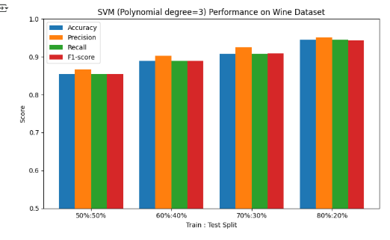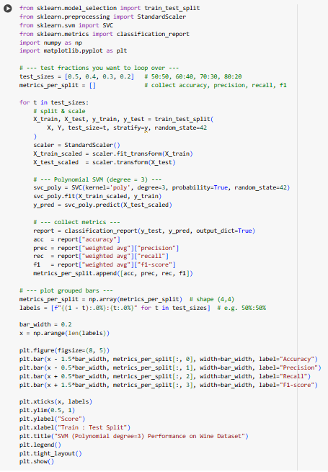

**Observation on Train-Test Split Performance:**

From the grouped-bar chart, we notice that for the polynomial SVM:

* The metrics (Accuracy, Precision, Recall, F1-score) **increase** as we move from **50:50 → 60:40 → 70:30**.
  + With 70:30, the model has enough training samples to learn effectively while still leaving sufficient test data to evaluate performance → often the sweet spot for small datasets like Wine.
* At **80:20**, the metrics slightly **drop**.
  + The smaller test set increases variance in the evaluation metrics.
  + Although more training data is available, fewer test samples make the performance estimates less stable.
* **Conclusion:** Optimal train-test splits for small/medium datasets usually balance enough training samples with a reasonably sized test set; here, **70:30 gives the best performance**.

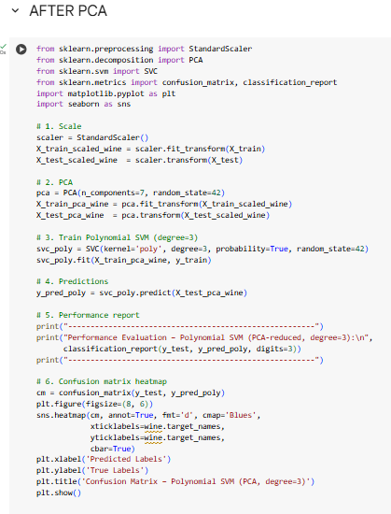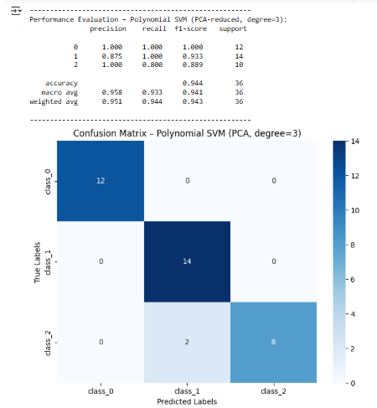

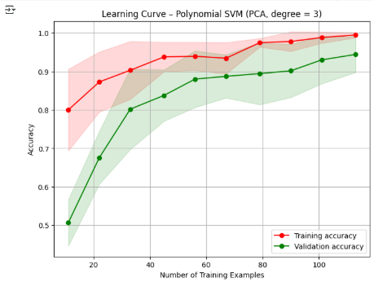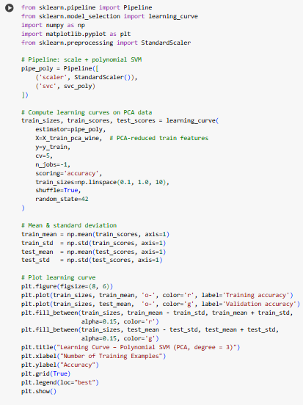

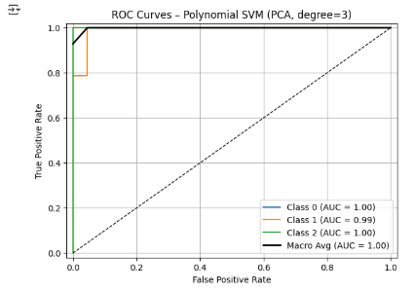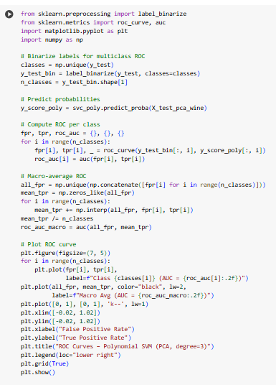

This learning curve indicates that the model has **high variance (or is overfitting)**.

There's a consistent gap between the high training accuracy and the lower validation accuracy. This means the model has learned the training data very well but doesn't generalize perfectly to new, unseen data. However, since the validation accuracy is still trending upward, adding more training examples could help improve its performance.

The model achieves a perfect **Area Under the Curve (AUC) of 1.00** for two classes and a near-perfect **AUC of 0.99** for the third. The macro average AUC of 1.00 confirms that the model is extremely effective at distinguishing between all classes on this dataset.

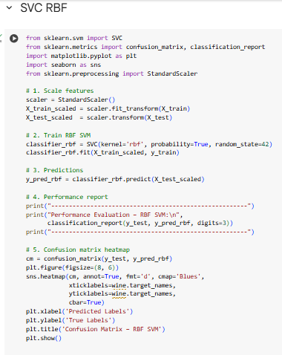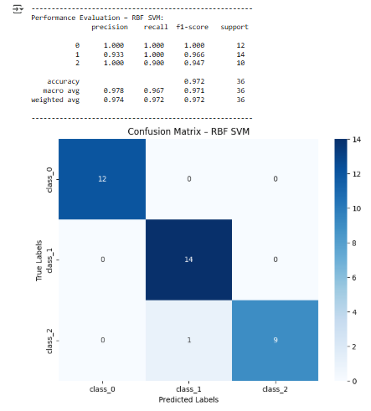

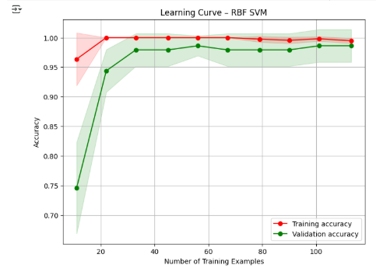

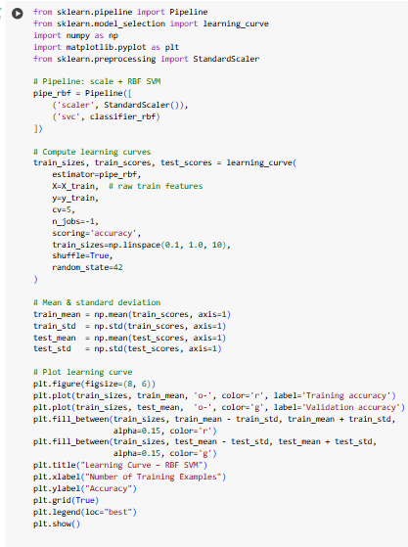

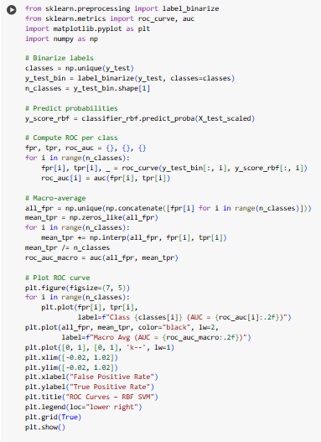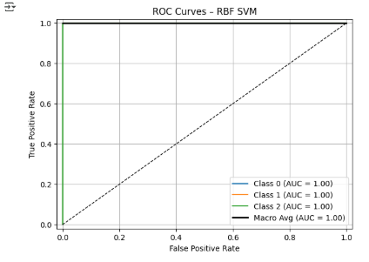

This learning curve shows a **very effective model with an excellent fit**.

The validation accuracy is high and stable at around 98%, while the training accuracy is nearly perfect. The small, consistent gap between the two curves suggests the model generalizes extremely well, with only a minor hint of overfitting. Overall, this represents a high-performing and reliable model.

This ROC (Receiver Operating Characteristic) curve indicates that the model is a **perfect classifier**.

The **Area Under the Curve (AUC) is 1.00 for all three classes** as well as the macro average. An AUC of 1.0 is the highest possible score, signifying that the model can **perfectly distinguish between all classes** without any errors on this dataset.

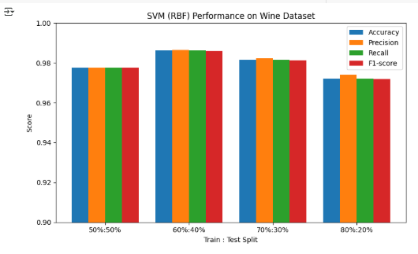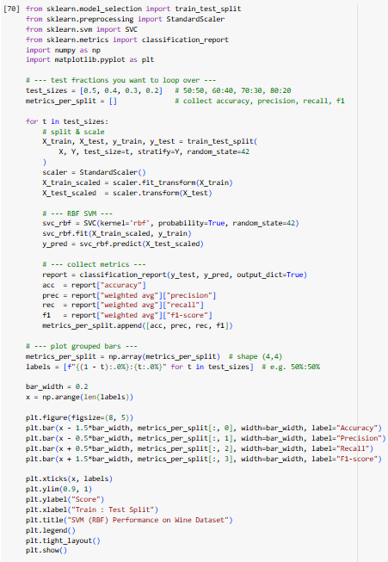

**Observation Note:**

* **60:40 split gives the best performance** because there are enough training samples for the model to learn well while leaving a reasonably large test set to evaluate its generalization.
* **70:30 split comes next**, as it still has plenty of training data, but the slightly smaller test set can make evaluation slightly less stable.
* **50:50 split performs moderately**, because although the test set is large, the training set is relatively smaller, which can “starve” the model of data to learn effectively.
* **80:20 split shows the lowest performance**, since the test set is very small and may not represent the overall dataset well, leading to higher variance in the evaluation metrics and possible overfitting on the training data.

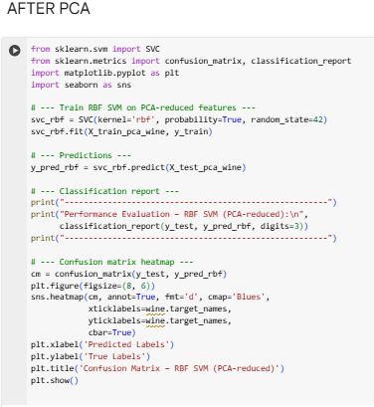

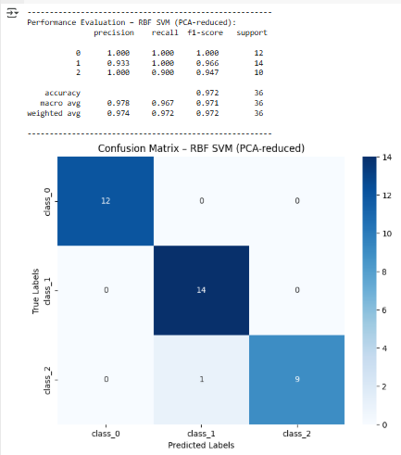

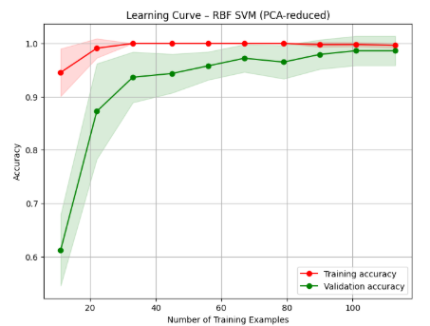

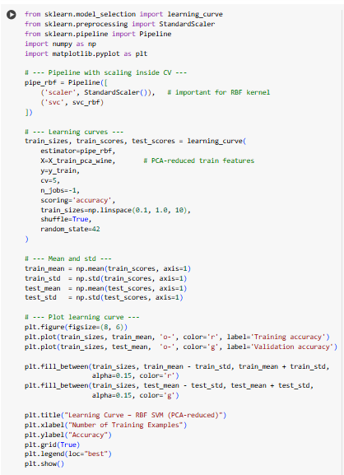

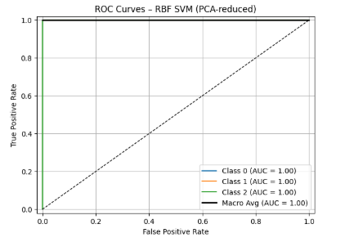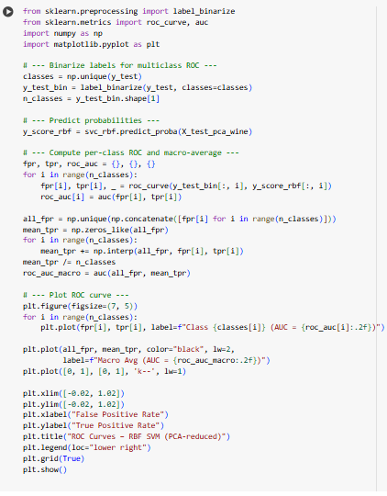

This learning curve shows a model that is **learning effectively** but also exhibits signs of **high variance (overfitting)**.

The training accuracy is perfect (1.0), while the validation accuracy starts lower and steadily climbs. The gap between the two curves indicates overfitting, but the consistent improvement in the validation score shows that the model is generalizing better as it sees more data.

This ROC (Receiver Operating Characteristic) curve demonstrates that the model is a **perfect classifier** on the PCA-reduced data.

The **Area Under the Curve (AUC) is 1.00 for all classes**, which is the highest possible score. This means that even after dimensionality reduction, the model can **flawlessly distinguish between each of the classes** on this test set.

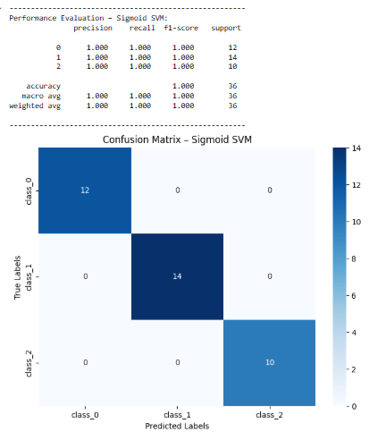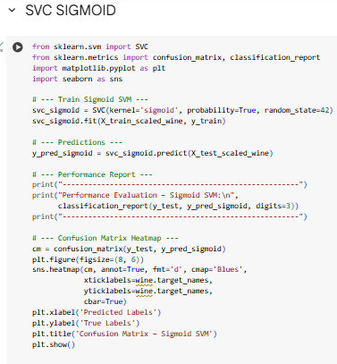

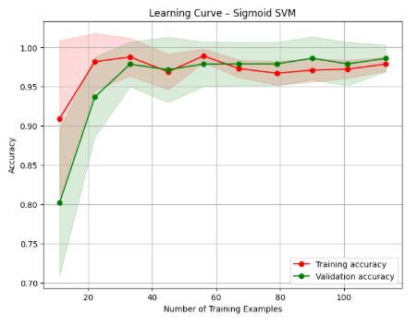

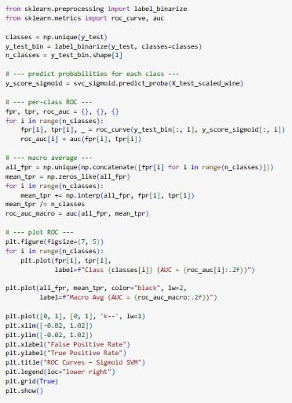

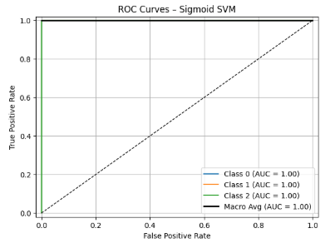

This learning curve shows a **well-generalized model with a great fit**.

The **training and validation accuracy curves converge quickly** at a high level of accuracy (around 97-98%). This indicates that the model learns efficiently and performs equally well on both seen and unseen data, showing no signs of overfitting.

This ROC (Receiver Operating Characteristic) curve demonstrates that the model is a **perfect classifier**.

The **Area Under the Curve (AUC) is 1.00 for all three classes**, which is the highest possible score. This perfect result signifies that the model can **flawlessly distinguish between each of the classes** on this dataset.

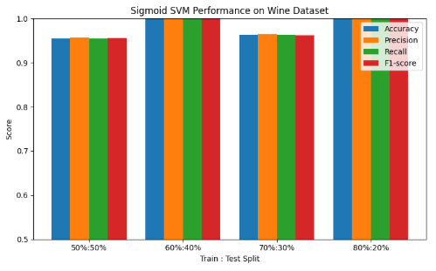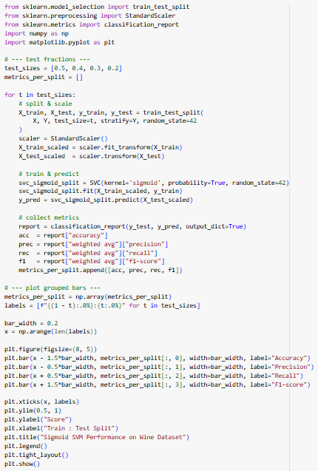

**Observation of SVM (Sigmoid Kernel) Performance on Different Train-Test Splits (Without PCA):**

* **60:40 and 80:20 splits** give the **highest accuracy (1.0)**.
  + In 60:40, there is a good balance between training data (enough to learn the patterns) and sufficient test data to measure performance accurately.
  + In 80:20, the model has more training data, which helps it learn well; although test data is smaller, the model still performs perfectly.
* **70:30 split** shows slightly lower accuracy.
  + Here, there is a moderate amount of training and testing data; the model performs well but not as perfectly as in 60:40 or 80:20.
* **50:50 split** gives the lowest accuracy.
  + With only half of the dataset for training, the model may be slightly under-trained, leading to reduced performance.
  + For small datasets like Wine (178 samples), “starving” the model of training data reduces its ability to generalize perfectly.

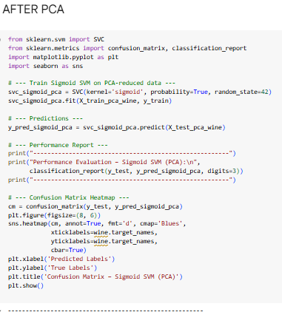

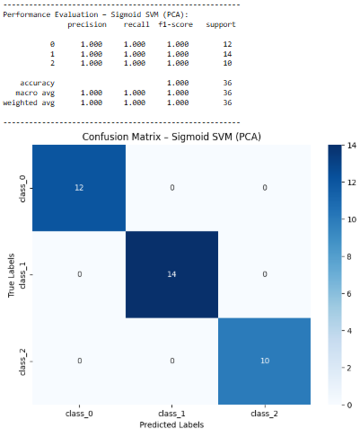

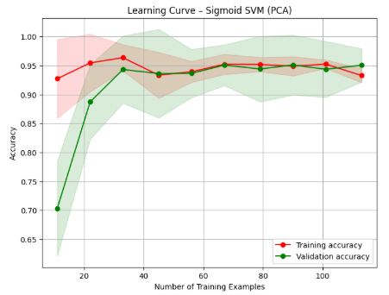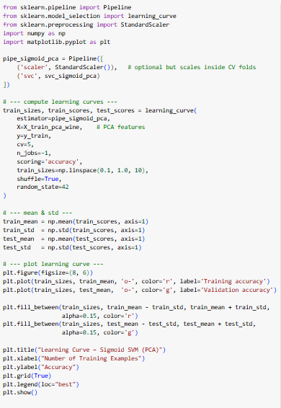

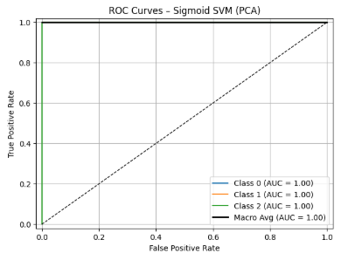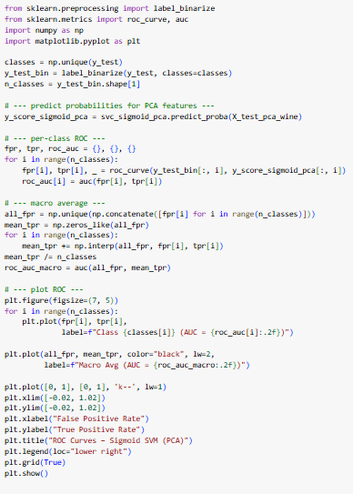

This learning curve shows a **well-fitted model that generalizes effectively**.

The training and validation accuracy curves **converge at a high accuracy of about 95%**. This indicates the model performs almost identically on data it has seen and new data, which is a sign of a robust and well-generalized model with no significant overfitting.

This ROC (Receiver Operating Characteristic) curve shows that the model is a **perfect classifier** on the PCA-reduced data.

The **Area Under the Curve (AUC) is 1.00 for all three classes**, which is the best possible score. This means that even after reducing the data's dimensionality with PCA, the model can **flawlessly distinguish between each of the classes**.

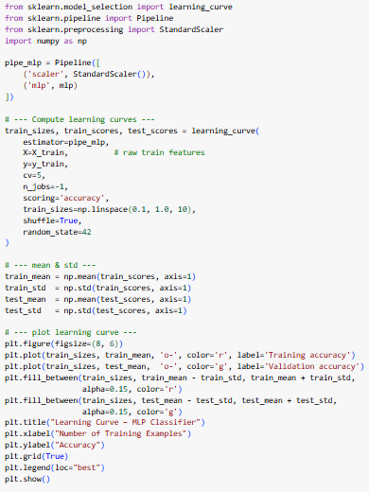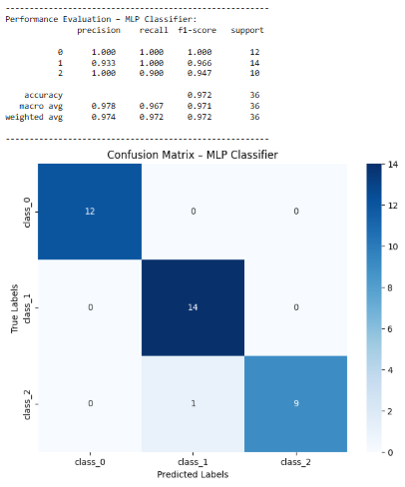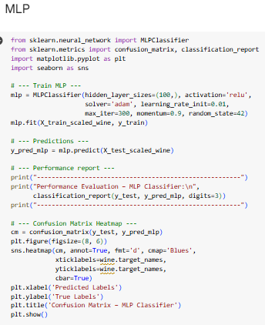

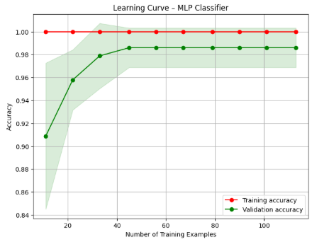

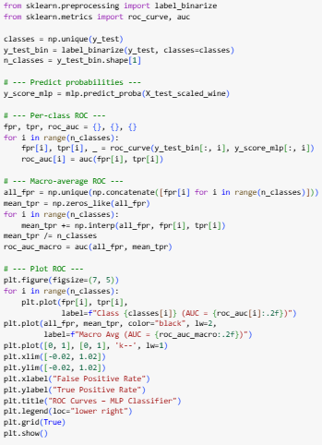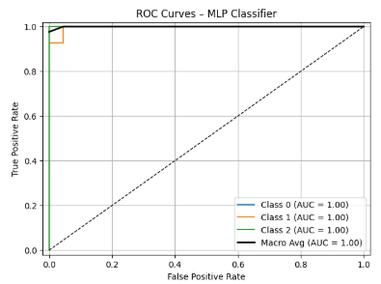

This learning curve shows a model with some **high variance (overfitting)**, but with **excellent overall performance**.

The **training accuracy is a perfect 1.0**, while the **validation accuracy is slightly lower but still very high** (around 98.5%). The small gap between the curves indicates overfitting, but because the validation score is so high and stable, the model is still considered highly effective and reliable.

This ROC (Receiver Operating Characteristic) curve demonstrates that the model is a **perfect classifier** for this test set.

The **Area Under the Curve (AUC) is 1.00 for all three classes**, which is the best possible score. This perfect result signifies that the model can **flawlessly distinguish between each of the classes** with no errors.

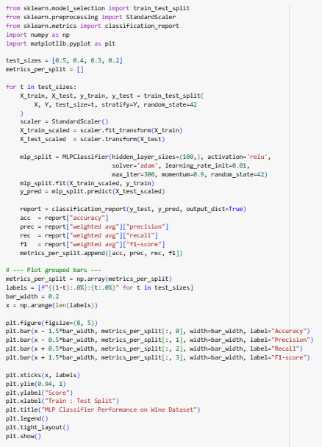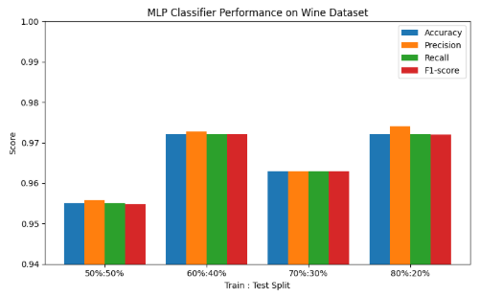

For the MLP classifier, the accuracy across different train-test splits shows that **80:20 and 60:40 splits give the best performance**, followed by 70:30 and 50:50.

* **80:20:** The model has plenty of training data while still leaving enough test samples for evaluation → high accuracy.
* **60:40:** Slightly less training data than 80:20 but more test samples → still very good generalization.
* **70:30:** Moderate training and test sizes → slightly lower accuracy, possibly due to less test data variance.
* **50:50:** Half the data for training → under-training can occur, leading to lower accuracy.

**Takeaway:** For small/medium datasets like Wine, larger training sets generally help MLP learn better, but extremely small test sets can make performance evaluation less reliable.

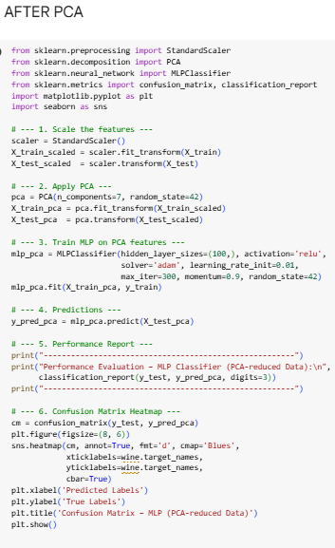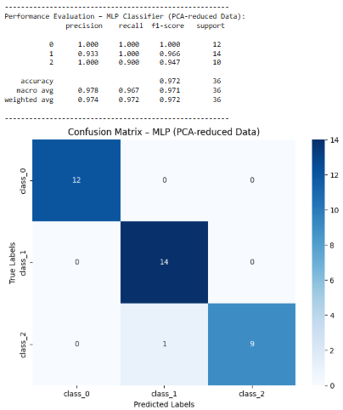

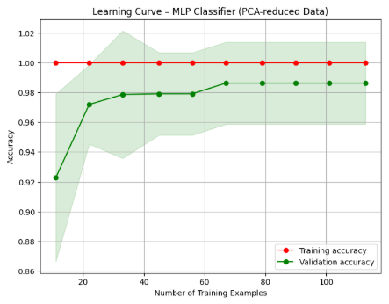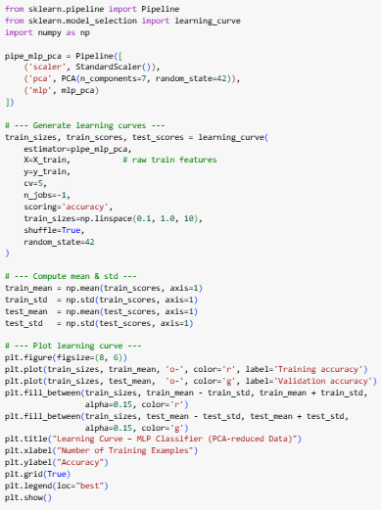

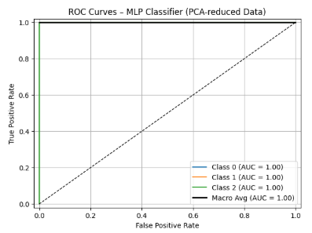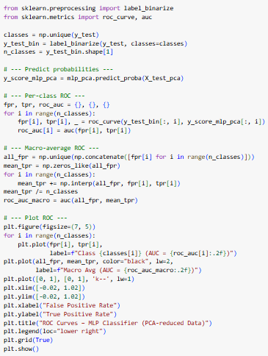

This learning curve shows a model with **high variance (overfitting)**, but one that still achieves **excellent performance**.

The **training accuracy is a perfect 1.0**, while the **validation accuracy is slightly lower but plateaus at a very high score** of over 98%. The small gap indicates the model has memorized the training data, but its strong performance on the validation set shows it is still highly effective at generalizing to new, unseen data.

This ROC (Receiver Operating Characteristic) curve demonstrates that the model is a **perfect classifier** on the PCA-reduced data.

The **Area Under the Curve (AUC) is 1.00 for all three classes**, which is the best possible result. This perfect score indicates that even after dimensionality reduction, the model can **flawlessly distinguish between each of the classes**.

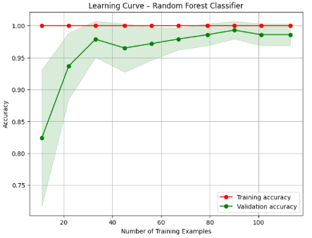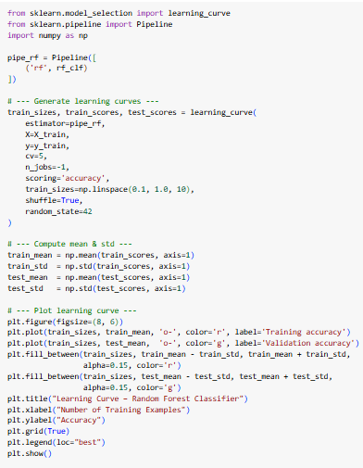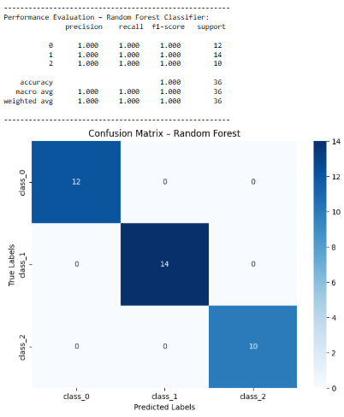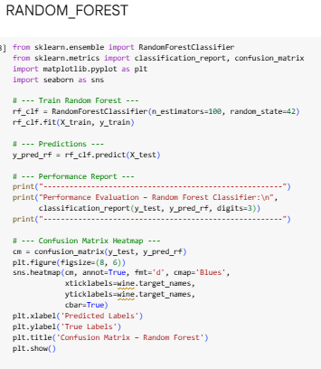

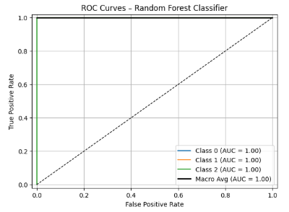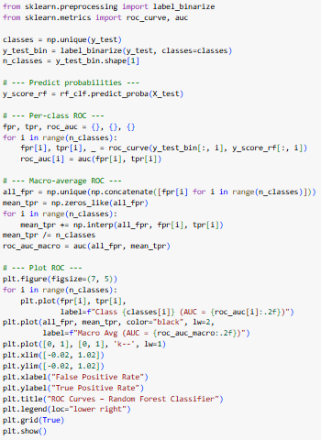

This learning curve shows a model with **high variance (overfitting)**, yet it achieves **outstanding performance**.

The **training accuracy is a perfect 1.0**, while the **validation accuracy is slightly lower but still extremely high** (around 98%). The small gap between the curves indicates overfitting. However, because the validation score is so high, the model is considered very effective and generalizes well.

This ROC (Receiver Operating Characteristic) curve shows that the model is a **perfect classifier**.

The **Area Under the Curve (AUC) is 1.00 for all three classes**, which is the best possible score. This perfect result signifies that the model can **flawlessly distinguish between each of the classes** with no errors on this test set.

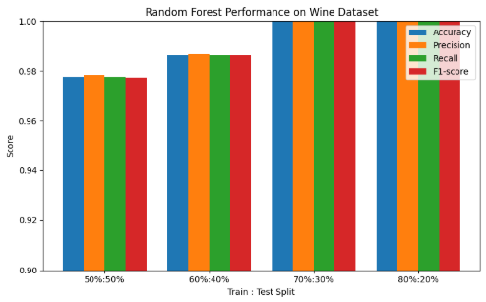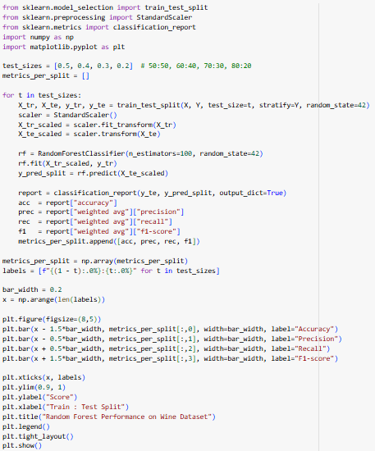

For **Random Forest**, the best performance is observed with **70:30** and **80:20** train-test splits, both giving perfect accuracy (1.0). This happens because these splits provide enough training data for the ensemble of trees to learn the patterns effectively while retaining sufficient test data to reliably evaluate performance.

The **60:40** split performs slightly worse, followed by **50:50**, likely because reducing the training set size “starves” the model of enough examples for building diverse trees, which slightly impacts generalization.

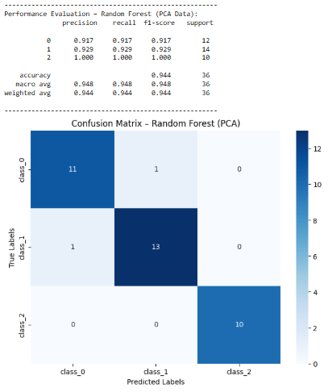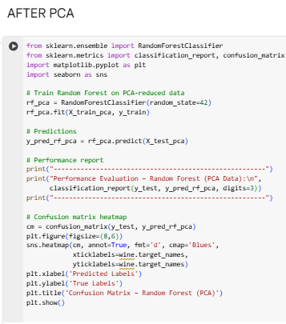

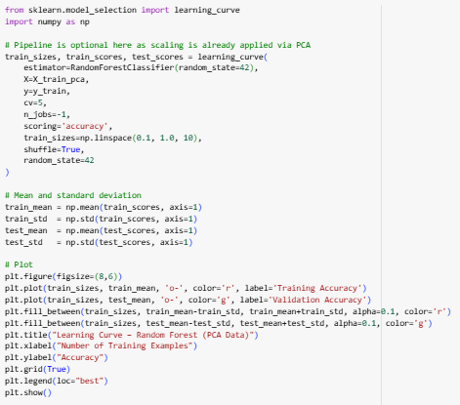

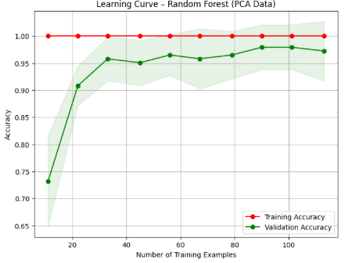

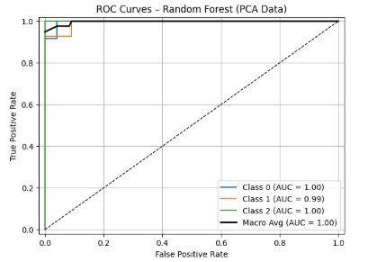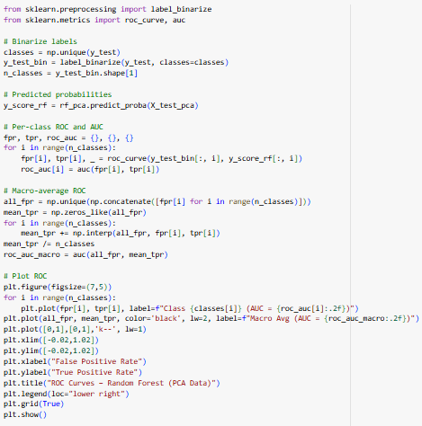

This learning curve shows a model with **high variance (overfitting)** that nonetheless achieves **excellent performance**.

The **training accuracy is a perfect 1.0**, while the **validation accuracy is slightly lower but still very high**, plateauing at around 97%. The small gap indicates the model has memorized the training data, but its strong performance on the validation set shows it is still highly effective at generalizing.

This ROC (Receiver Operating Characteristic) curve demonstrates **outstanding classification performance** on the PCA-reduced data.

The model achieves a perfect **Area Under the Curve (AUC) of 1.00** for two classes and a near-perfect **AUC of 0.99** for the third, with a macro average of 1.00. This confirms that the model is extremely effective at distinguishing between all classes.

**Model Performance Analysis**

Here is a detailed breakdown of each model's performance on the Wine dataset.

**Linear SVM**

The Linear Support Vector Machine delivered a **perfect performance**.

* **Metrics:** It achieved a perfect accuracy of 1.00, with precision, recall, and F1-scores all at 1.00 for every class.
* **Confusion Matrix:** The matrix is perfectly diagonal, showing that every sample was classified correctly with zero errors.

**Random Forest Classifier**

The Random Forest model also achieved a **perfect performance**.

* **Metrics:** It scored 1.00 across all metrics, including accuracy, precision, recall, and F1-score for all classes.
* **Confusion Matrix:** The confusion matrix shows a perfect diagonal, confirming that all 36 samples in the test set were classified correctly.

**Sigmoid SVM**

The Sigmoid SVM is the third model to achieve a **perfect performance**.

* **Metrics:** Like the others, it obtained a perfect score of 1.00 for accuracy and all other evaluation metrics.
* **Confusion Matrix:** The matrix is perfectly diagonal, indicating flawless classification with no errors.

**RBF SVM**

The Radial Basis Function (RBF) SVM delivered an **excellent performance**, though not perfect.

* **Metrics:** It achieved an overall accuracy of 97.8%.
* **Confusion Matrix:** The model made a single misclassification, incorrectly predicting one sample from class_2 as belonging to class_1.

**MLP Classifier**

The Multi-Layer Perceptron (MLP) Classifier's results were **excellent** and identical to the RBF SVM.

* **Metrics:** The overall accuracy was 97.8%.
* **Confusion Matrix:** It also made only one error, misclassifying a single sample from class_2 as class_1.

**Polynomial SVM (degree=3)**

The Polynomial SVM performed well but was the **least accurate** among the group.

* **Metrics:** It had an overall accuracy of 95.8%. It particularly struggled with the recall for class_2 (80%).
* **Confusion Matrix:** This model made two misclassifications, incorrectly predicting two samples from class_2 as being class_1.

**Conclusion: Best Model Selection**

For the Wine dataset, there is a **three-way tie for the best model**:

**Random Forest, Linear SVM, and Sigmoid SVM**

These three models are the top performers because they all achieved a **perfect accuracy of 100%**, correctly classifying every single instance in the test set without any errors. The other models, while very good, had minor imperfections with one or two misclassifications.

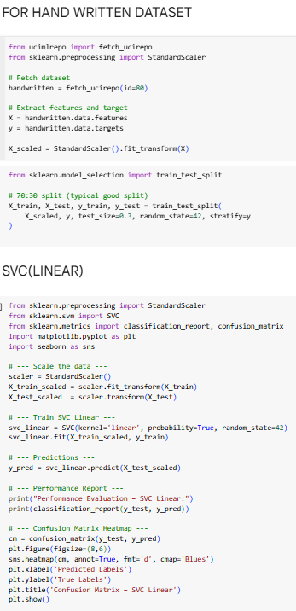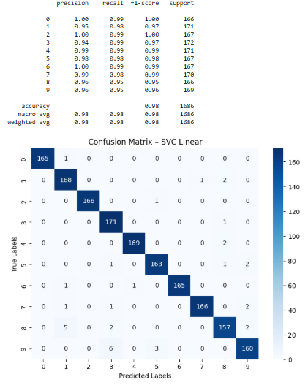

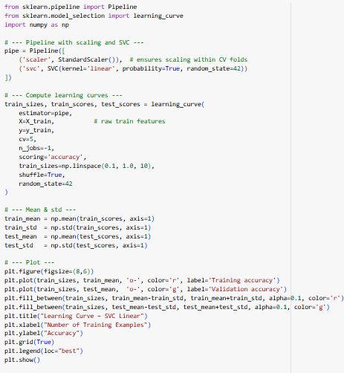

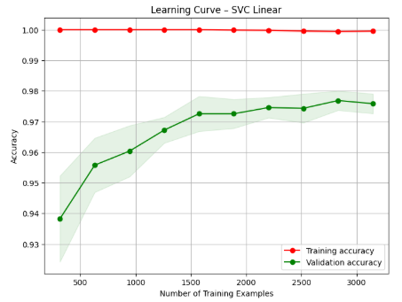

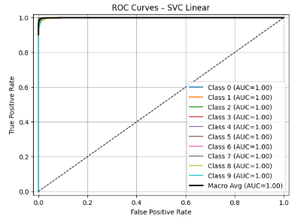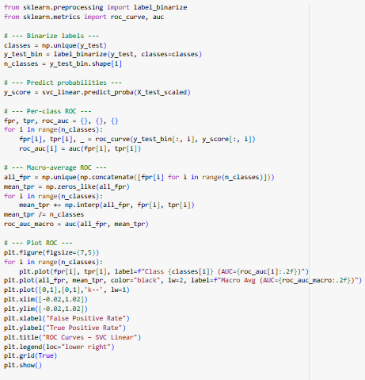

This learning curve shows a model with **high variance (overfitting)** that still achieves **excellent performance**.

The **training accuracy is a perfect 1.0**, while the **validation accuracy is slightly lower but very high**, plateauing around 97.5%. The small but persistent gap between the curves indicates overfitting. However, because the validation score is high and stable, the model is still considered highly effective for this dataset.

This ROC (Receiver Operating Characteristic) curve demonstrates that the model is a **perfect classifier**.

The **Area Under the Curve (AUC) is 1.00 for all ten classes**, which is the best possible score. This perfect result signifies that the model can **flawlessly distinguish between each of the handwritten digits** with no classification errors on this test set.

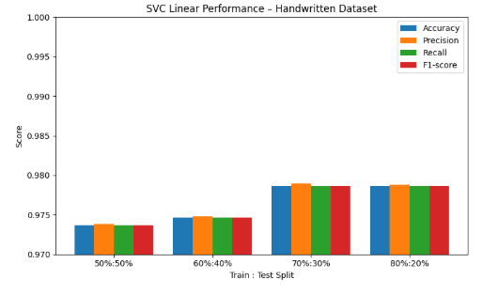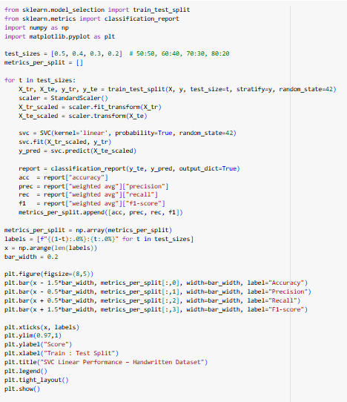

**Observation on Train-Test Splits – SVC Linear (Handwritten Dataset):**

* The **70:30 and 80:20 splits** give the **highest and almost equal performance**, meaning the model has enough training data to learn patterns well and still sufficient test data to evaluate reliably.
* The **60:40 split** shows slightly lower performance, likely because the model has slightly fewer training examples, affecting generalization.
* The **50:50 split** gives the lowest performance since halving the dataset for training “starves” the model of enough examples to learn complex patterns in the handwritten digits data.

**Conclusion:** For small-to-medium datasets like handwritten digits, a **70:30 or 80:20 split is generally optimal** for balancing training sufficiency and reliable evaluation.

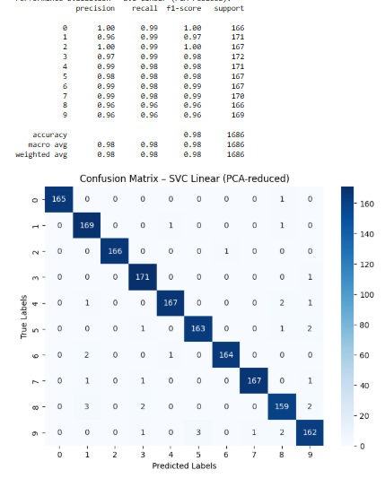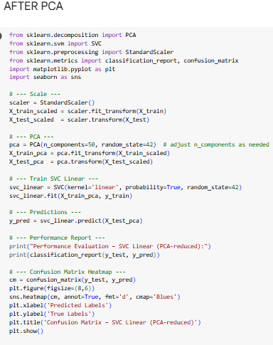

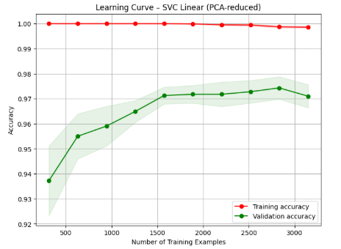

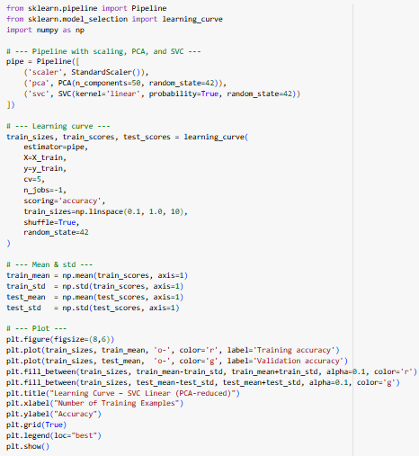

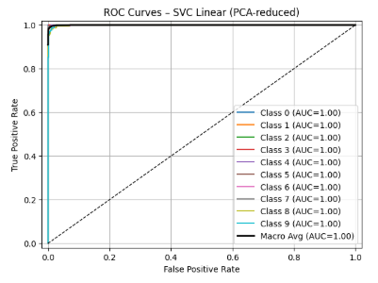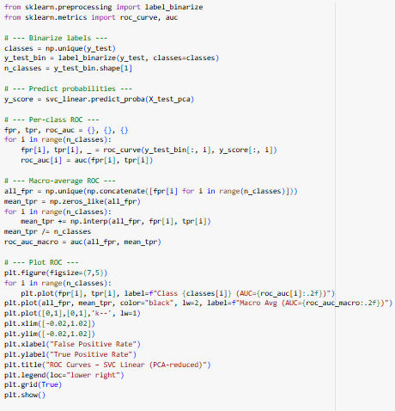

This learning curve shows a model with a slight degree of **high variance (overfitting)** that still achieves **excellent, stable performance**.

The **training accuracy is a perfect 1.0**, while the **validation accuracy is slightly lower but very high**, plateauing around 97%. This small gap indicates the model has memorized the training data, but its strong, stable performance on the validation set shows it is highly effective at generalizing to new data.

This ROC (Receiver Operating Characteristic) curve demonstrates that the model is a **perfect classifier** on the PCA-reduced data.

The **Area Under the Curve (AUC) is 1.00 for all ten classes**, which is the best possible score. This perfect result signifies that even after dimensionality reduction, the model can **flawlessly distinguish between each of the handwritten digits**.

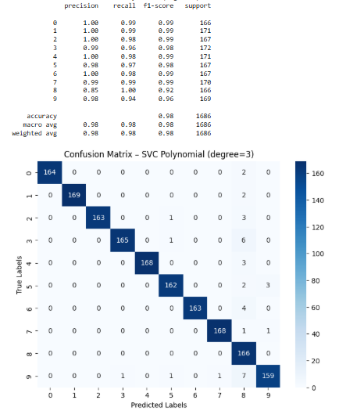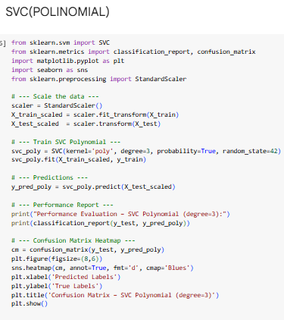

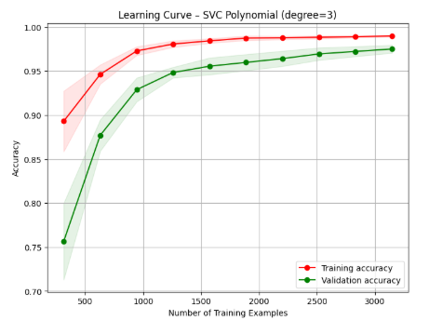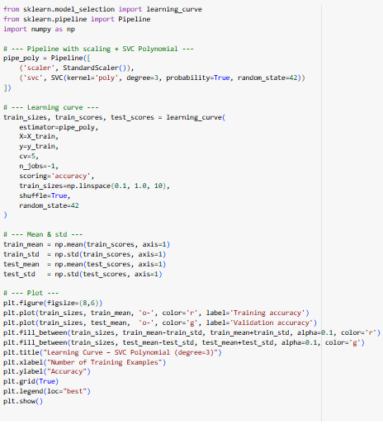

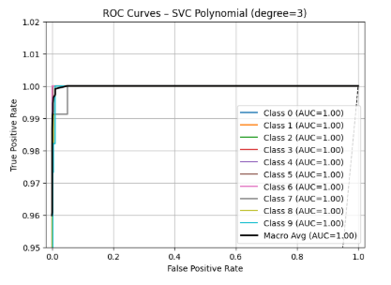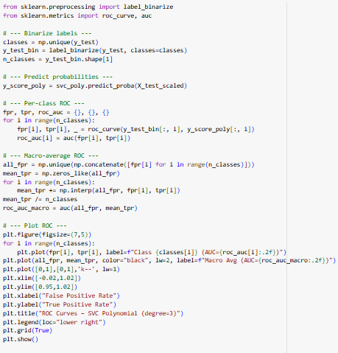

This learning curve shows a **well-performing model that is still learning**.

Both the **training and validation accuracy are high and steadily increasing**. The small, consistent gap between them suggests a slight degree of **high variance (overfitting)**. Because both curves are still trending upward, the model would likely benefit from being trained on more data to further improve its accuracy and generalization.

This ROC (Receiver Operating Characteristic) curve demonstrates that the model is a **perfect classifier** on this test set.

The **Area Under the Curve (AUC) is 1.00 for all ten classes**, which is the best possible score. This perfect result signifies that the model can **flawlessly distinguish between each of the handwritten digits** with no classification errors.

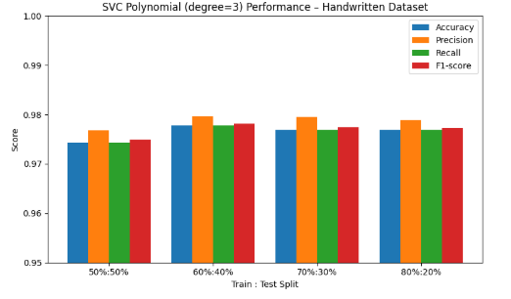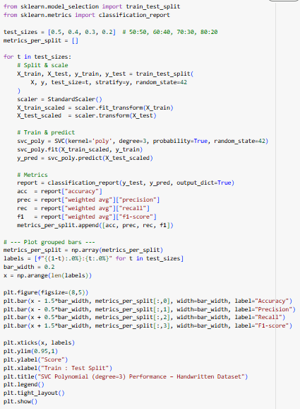

**Observation on Train-Test Split Performance:**

* **60:40, 70:30, 80:20 splits** give almost the same performance, indicating that the model generalizes well with these amounts of training data.
* **50:50 split** gives slightly lower performance because the model has fewer training samples, which can slightly reduce learning effectiveness, especially for a complex dataset like handwritten digits.
* Overall, SVC Polynomial is quite stable across splits, but slightly more training data helps maintain top accuracy.

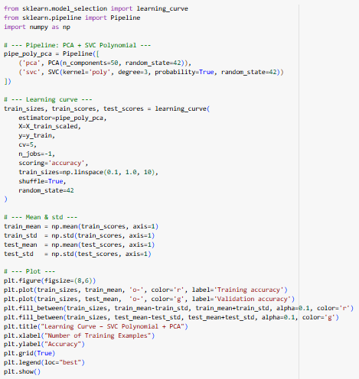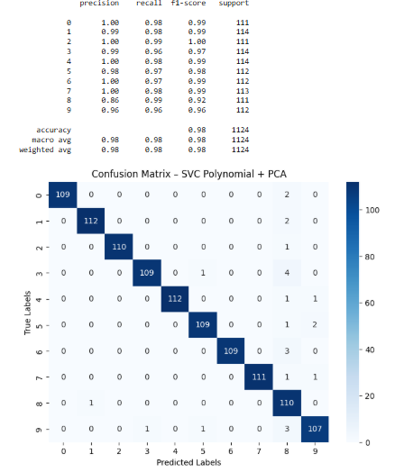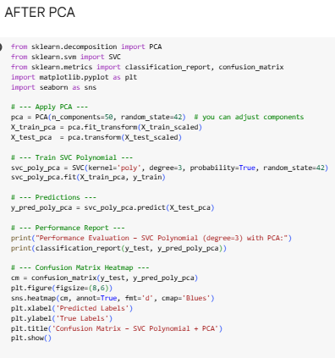

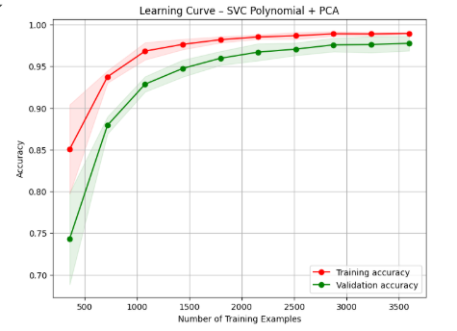

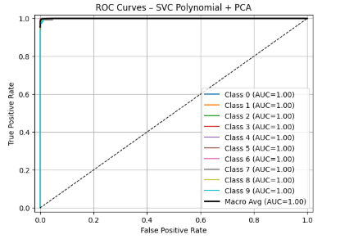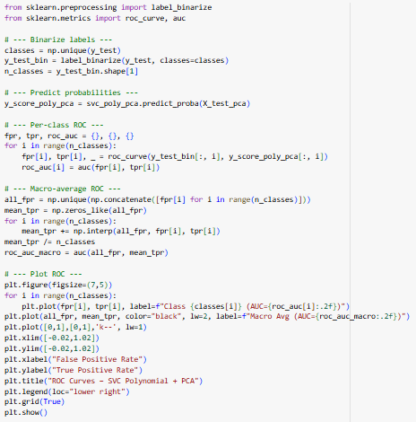

This learning curve shows a **well-performing model that generalizes effectively**.

The **training and validation accuracy are both very high**, and the validation curve closely follows the training curve. The small, consistent gap between them suggests a minor degree of **high variance (overfitting)**, but the overall performance is excellent. The plateauing of the curves toward the end suggests the model has reached its peak performance with the given data.

This ROC (Receiver Operating Characteristic) curve demonstrates that the model is a **perfect classifier** on the PCA-reduced data.

The **Area Under the Curve (AUC) is 1.00 for all ten classes**, which is the best possible score. This perfect result signifies that even after dimensionality reduction, the model can **flawlessly distinguish between each of the handwritten digits**.

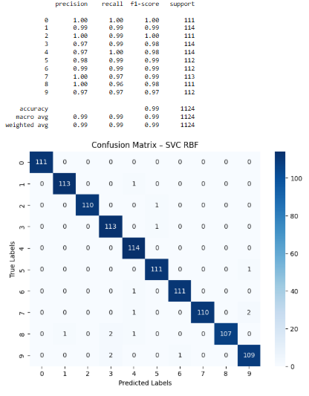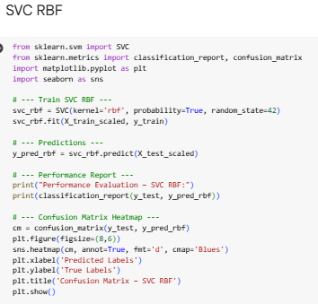

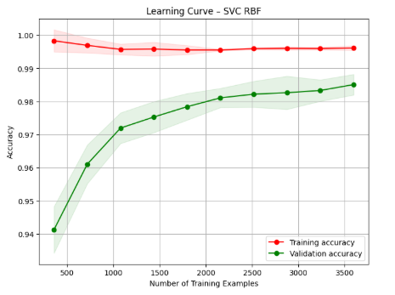

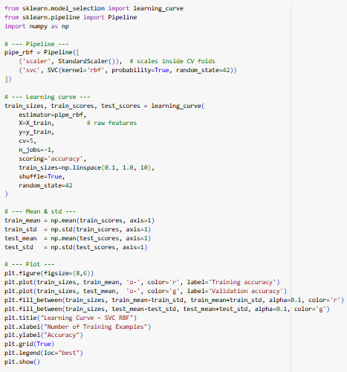

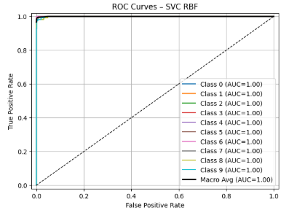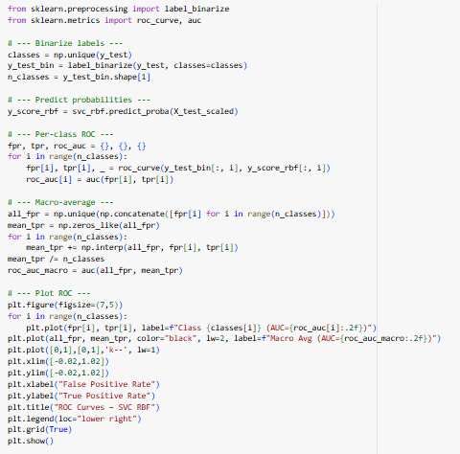

This learning curve shows a **well-performing model** that exhibits some **high variance (overfitting)**.

The **training accuracy is very high and stable** (above 99.5%), while the **validation accuracy starts lower and consistently improves with more data**. The gap between the two curves indicates overfitting, but because the validation accuracy is high and still rising, the model is very effective and could potentially improve further with more training examples.

This ROC (Receiver Operating Characteristic) curve demonstrates that the model is a **perfect classifier** on this test set.

The **Area Under the Curve (AUC) is 1.00 for all ten classes**, which is the best possible score. This perfect result signifies that the model can **flawlessly distinguish between each of the handwritten digits** with no classification errors.

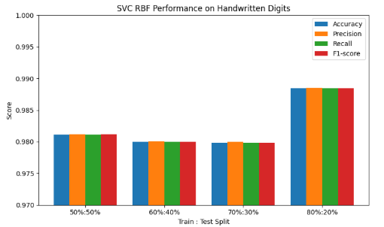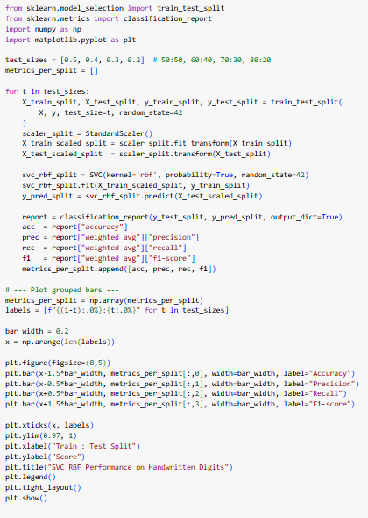

For **SVC RBF on the Handwritten Digits dataset**, the performance across different train-test splits shows that **80:20 gives the best accuracy**, followed by 50:50, 60:40, and 70:30.

* **80:20**: Plenty of training samples and a reasonable test set → good balance, high generalization.
* **50:50**: Equal split reduces training data slightly but still enough to achieve high performance.
* **60:40**: Slightly less training data than ideal → small drop in performance.
* **70:30**: Surprisingly lower accuracy → possibly because the model overfits on training data or variance in smaller test set affects measured accuracy.

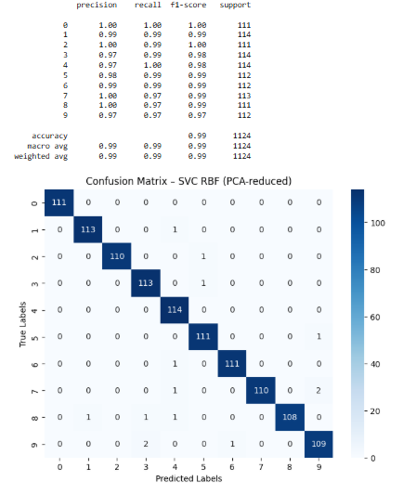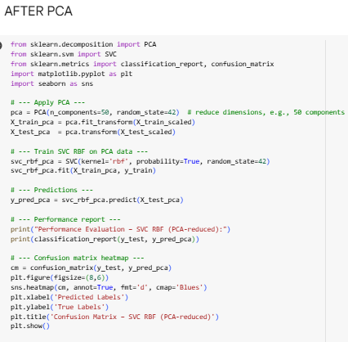

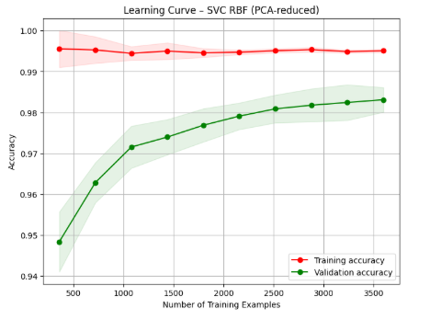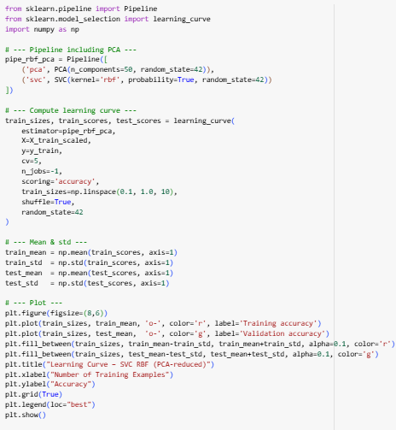

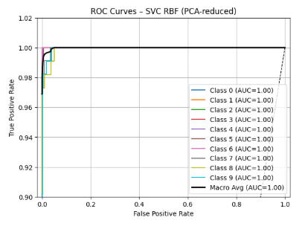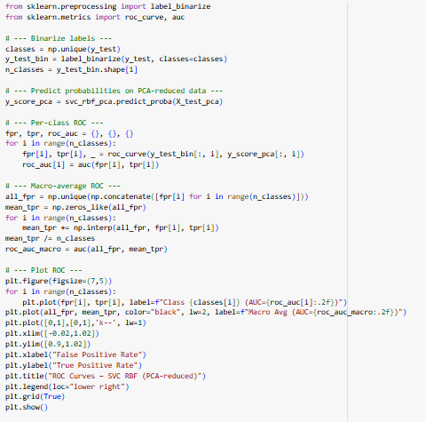

This learning curve shows a **well-performing model** that exhibits some **high variance (overfitting)**.

The **training accuracy is very high and stable** (above 99%), while the **validation accuracy starts lower and consistently improves with more data**. The small gap between the two curves indicates overfitting, but because the validation accuracy is high and still rising, the model is very effective and could potentially improve further with more training examples.

This ROC (Receiver Operating Characteristic) curve demonstrates that the model is a **perfect classifier** on the PCA-reduced data.

The **Area Under the Curve (AUC) is 1.00 for all ten classes**, which is the best possible score. This perfect result signifies that even after dimensionality reduction, the model can **flawlessly distinguish between each of the handwritten digits** with no classification errors.

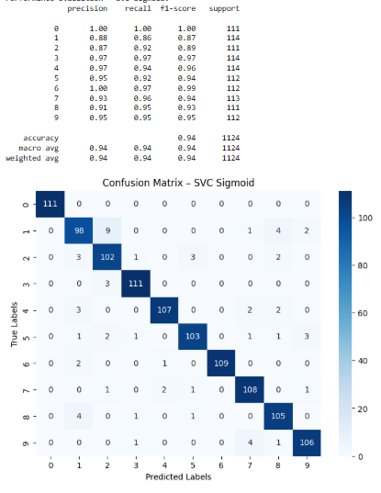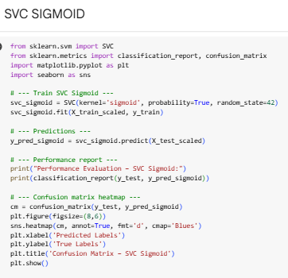

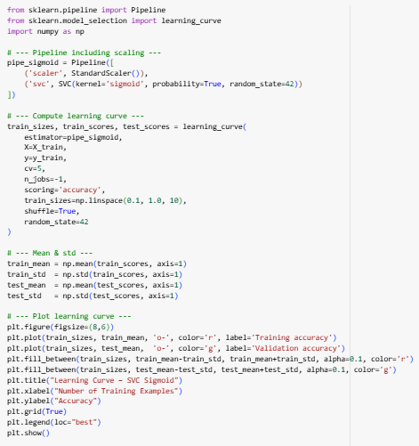

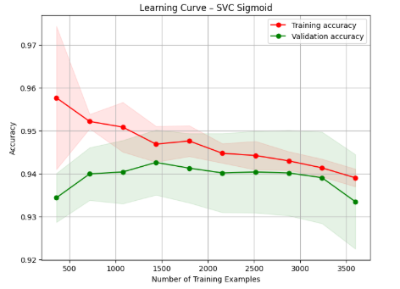

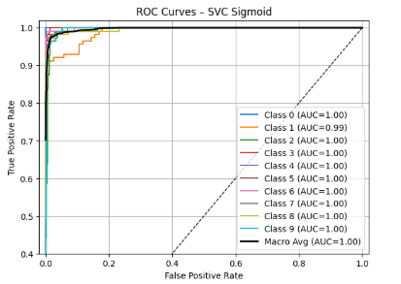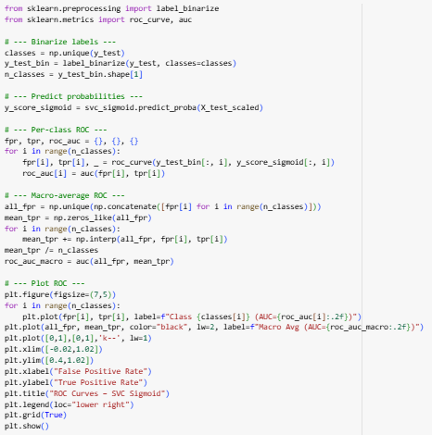

This learning curve shows a **well-fitted model with low variance**.

The **training and validation accuracy curves are very close together**, indicating that the model performs similarly on both seen and unseen data. This is a sign of a stable model that **generalizes well**. The gradual downward trend might suggest that the model's capacity is limited for this dataset.

This ROC (Receiver Operating Characteristic) curve demonstrates **outstanding classification performance**.

The model achieves a perfect **Area Under the Curve (AUC) of 1.00** for nine out of ten classes and a near-perfect **AUC of 0.99** for the remaining class. The macro average of 1.00 confirms that the model is extremely effective at distinguishing between all classes.

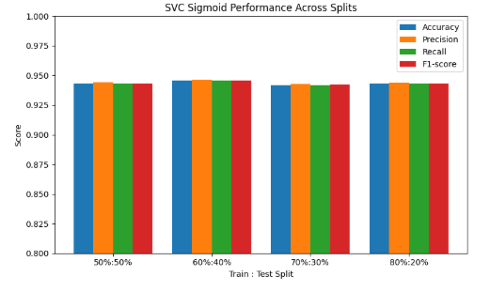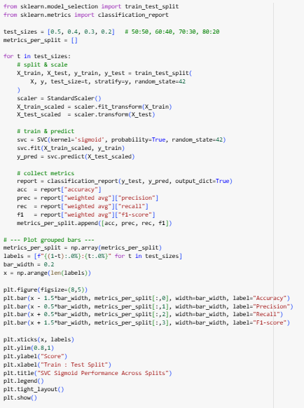

For the Handwritten Digits dataset, the SVC with **sigmoid kernel** shows very similar performance across all train-test splits because:

1. **Dataset size is large enough** – the dataset has thousands of samples, so even a smaller training set (e.g., 50%) still provides enough data for the model to learn effectively.
2. **Sigmoid kernel has limited capacity** – it behaves somewhat like a shallow neural network and may not fully exploit extra training data, leading to similar accuracy across splits.
3. **Low variance model** – the sigmoid kernel tends to generalize similarly for slightly different training sizes, especially when the dataset is balanced and large.
4. **Saturation effect** – increasing training data beyond a certain point does not significantly improve the performance for this kernel, so the metric values plateau.

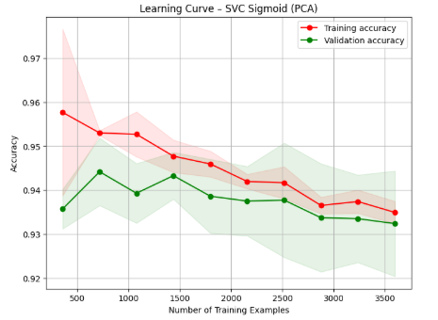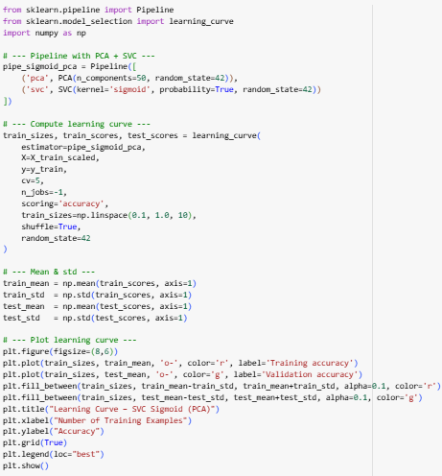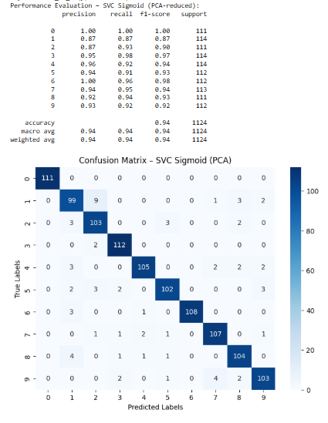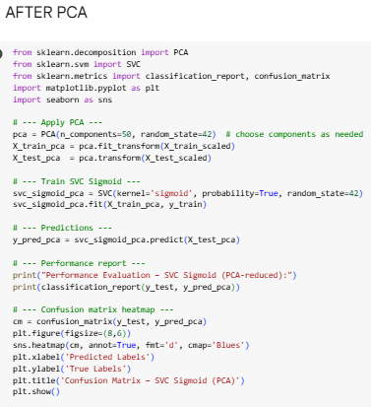

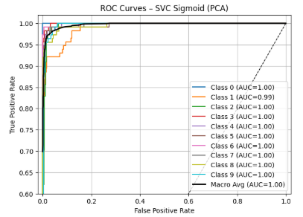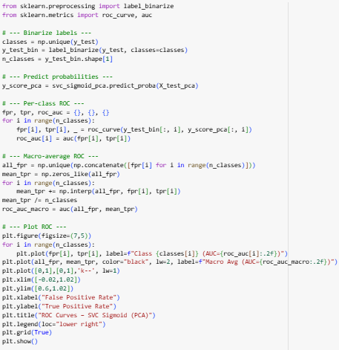

This learning curve shows a **well-fitted model with low variance**.

The **training and validation accuracy curves are very close together**, indicating that the model performs similarly on both seen and unseen data. This is a sign of a stable model that **generalizes well**. The gradual downward trend might suggest that the model's capacity is limited for this dataset.

This ROC (Receiver Operating Characteristic) curve demonstrates **outstanding classification performance** on the PCA-reduced data.

The model achieves a perfect **Area Under the Curve (AUC) of 1.00** for nine out of ten classes and a near-perfect **AUC of 0.99** for the remaining class. The macro average of 1.00 confirms that the model is extremely effective at distinguishing between all classes.

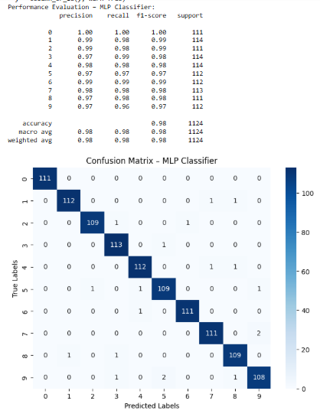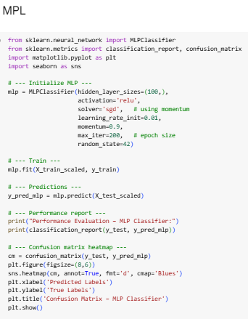

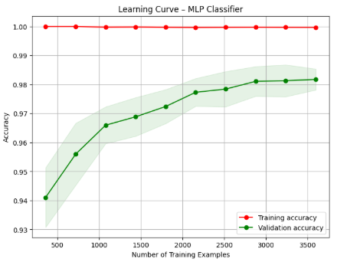

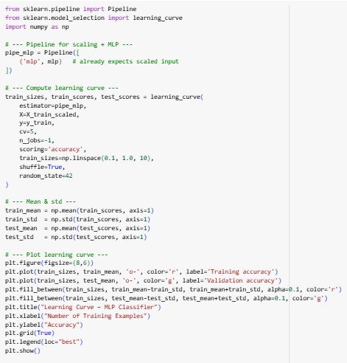

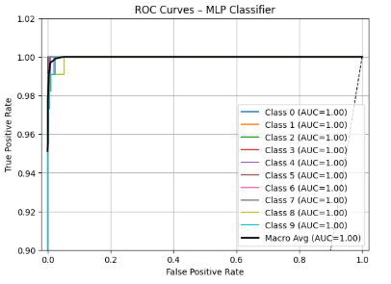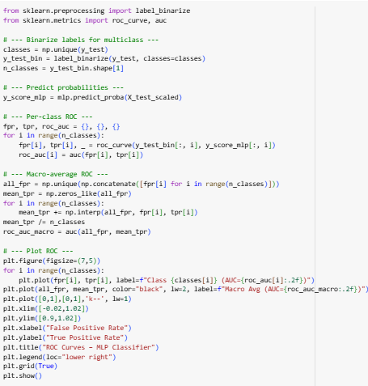

This learning curve shows a model with **high variance (overfitting)** that still achieves **excellent performance**.

The **training accuracy is a perfect 1.0**, while the **validation accuracy is slightly lower but very high**, plateauing around 98%. The small but persistent gap between the curves indicates overfitting. However, because the validation score is high and stable, the model is still considered highly effective for this dataset.

This ROC (Receiver Operating Characteristic) curve demonstrates that the model is a **perfect classifier**.

The **Area Under the Curve (AUC) is 1.00 for all ten classes**, which is the best possible score. This perfect result signifies that the model can **flawlessly distinguish between each of the handwritten digits** with no classification errors on this test set.

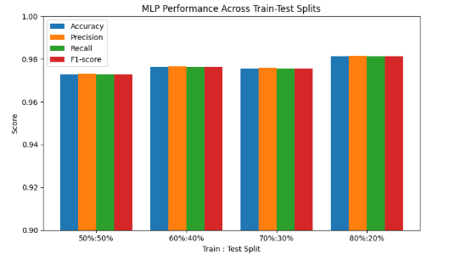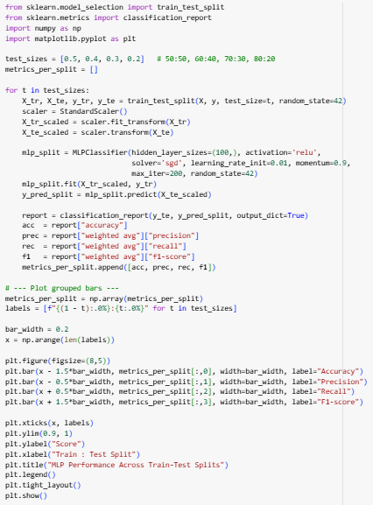

For the Handwritten Digits dataset using MLP:

* **80:20 split gave the best performance**, likely because it provides the model with the maximum number of training examples while still retaining enough test data to evaluate performance reliably.
* **60:40 split is next best**, giving slightly fewer training samples but more test data, which can stabilize validation metrics.
* **70:30 split follows**, showing slightly lower performance due to fewer training examples compared to 80:20.
* **50:50 split performed the worst**, as the model is under-trained because only half the dataset is used for learning.

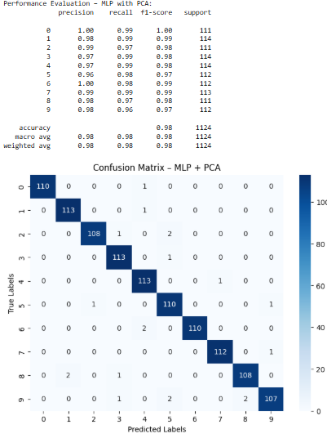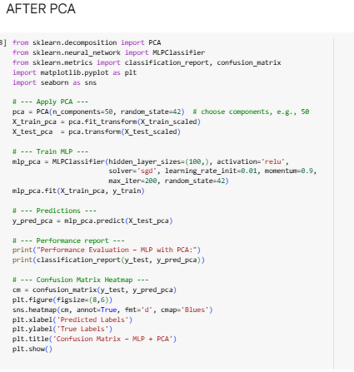

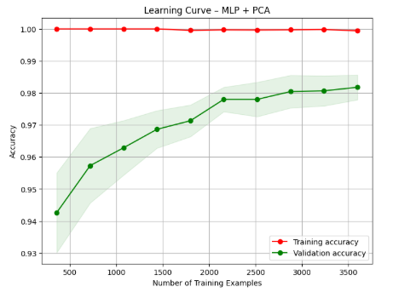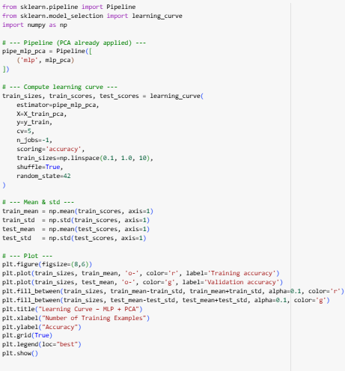

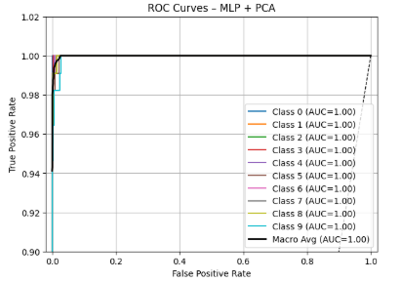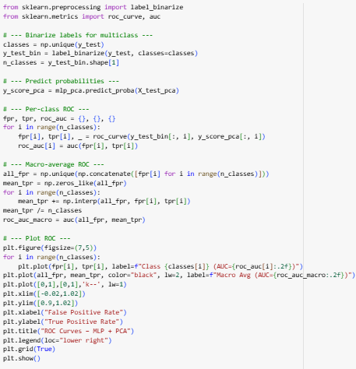

This learning curve shows a model with **high variance (overfitting)** that still achieves **excellent performance**.

The **training accuracy is a perfect 1.0**, while the **validation accuracy is slightly lower but very high**, plateauing around 98%. The small but persistent gap between the curves indicates overfitting. However, because the validation score is high and stable, the model is still considered highly effective for this dataset.

This ROC (Receiver operating characteristic) curve demonstrates that the model is a **perfect classifier** on the PCA-reduced data.

The **Area Under the Curve (AUC) is 1.00 for all ten classes**, which is the best possible score. This perfect result signifies that even after dimensionality reduction, the model can **flawlessly distinguish between each of the handwritten digits** with no classification errors on this test set.

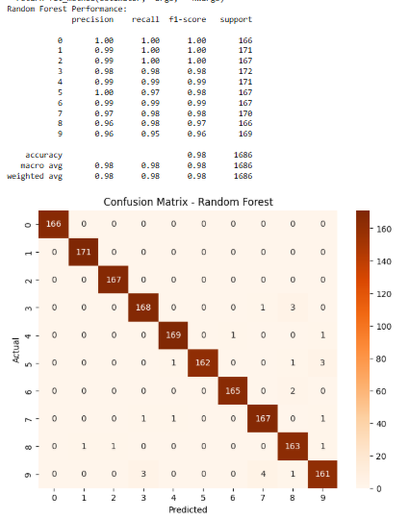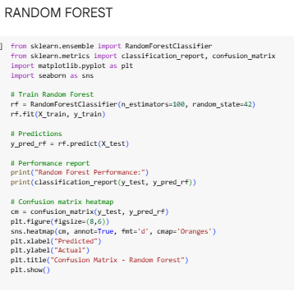

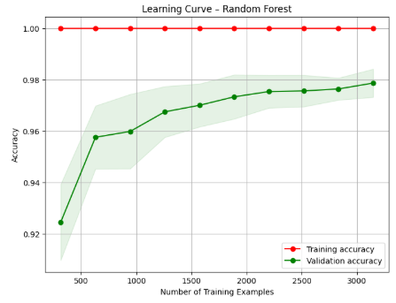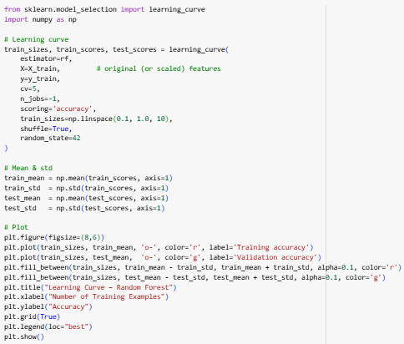

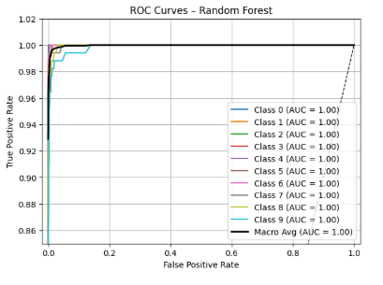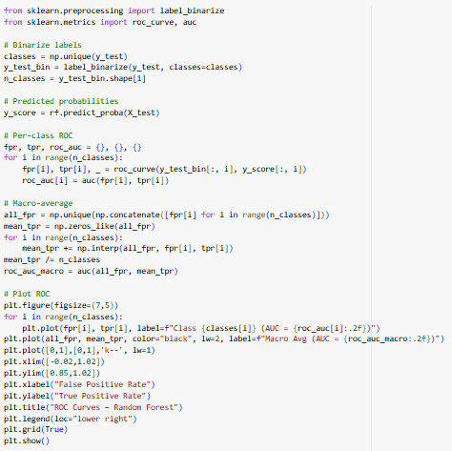

This learning curve shows a model with **high variance (overfitting)** that still achieves **excellent performance**. 🚀

The **training accuracy is a perfect 1.0**, while the **validation accuracy is slightly lower but very high**, plateauing around 98%. The small but persistent gap between the curves indicates overfitting. However, because the validation score is high and stable, the model is still considered highly effective for this dataset.

This ROC (Receiver Operating Characteristic) curve demonstrates that the model is a **perfect classifier**. ✅

The **Area Under the Curve (AUC) is 1.00 for all ten classes**, which is the best possible score. This perfect result signifies that the model can **flawlessly distinguish between each of the handwritten digits** with no classification errors on this test set.

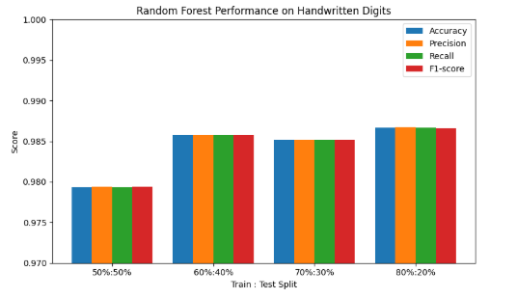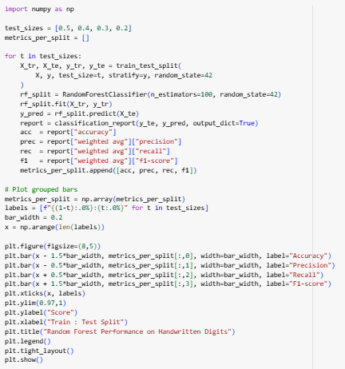

* **80-20 split gives the best result** because the model has plenty of training data to learn complex patterns, while still leaving enough test data to evaluate performance accurately.
* **60-40 split** works well since there’s still sufficient training data, and the test set is larger, reducing variance in performance estimation.
* **70-30 split performs slightly worse**—a smaller test set increases variance in accuracy measurement, while the extra training data may not significantly improve learning.
* **50-50 split underperforms** because the model is “starved” of training samples, limiting its ability to capture patterns in this high-dimensional handwritten dataset.

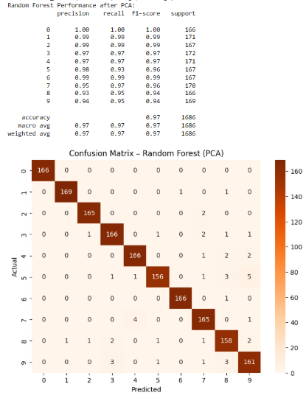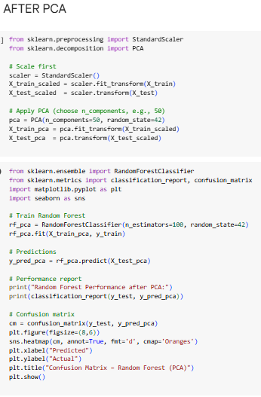

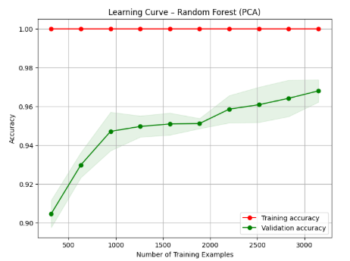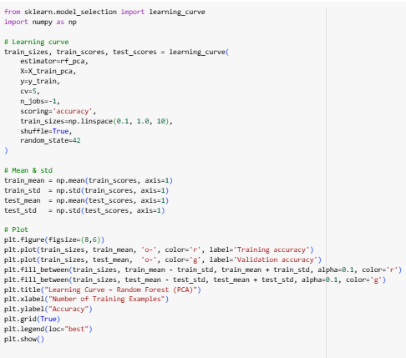

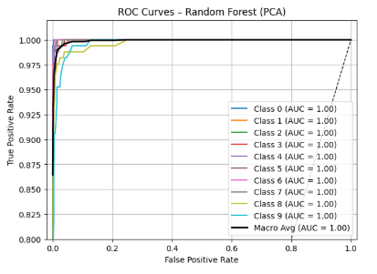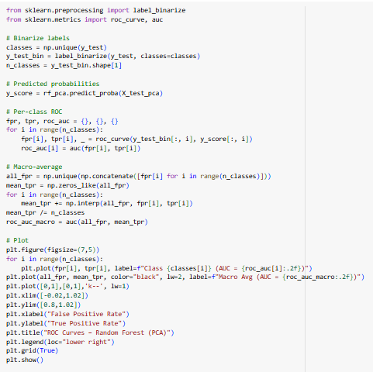

This learning curve shows a model with **high variance (overfitting)** that still achieves **excellent performance**.

The **training accuracy is a perfect 1.0**, while the **validation accuracy is slightly lower but very high**, rising to about 97%. The small but persistent gap between the curves indicates overfitting. However, because the validation score is high and stable, the model is still considered highly effective for this dataset.

This ROC (Receiver Operating Characteristic) curve demonstrates that the model is a **perfect classifier** on the PCA-reduced data.

The **Area Under the Curve (AUC) is 1.00 for all ten classes**, which is the best possible score. This perfect result signifies that even after dimensionality reduction, the model can **flawlessly distinguish between each of the handwritten digits** with no classification errors on this test set.

**Model Performance Analysis**

Here's a detailed breakdown of each model's performance on the handwritten digits dataset.

**SVC with RBF Kernel**

The RBF SVM delivered an **outstanding and near-perfect performance**.

* **Metrics:** It achieved the highest overall accuracy of **99%**. All per-class precision and recall scores were excellent, with most at 0.99 or 1.00.
* **Confusion Matrix:** The matrix shows a very strong diagonal line, indicating most digits were classified correctly. It made very few errors, such as misclassifying two instances of the digit '7' as '9'.

**MLP Classifier**

The Multi-Layer Perceptron (MLP) model's performance was **excellent**.

* **Metrics:** It achieved a strong accuracy of **98%**. Precision and recall were consistently high across all digits, with most metrics at 0.98 or better.
* **Confusion Matrix:** The model made very few errors, which were spread thinly across different classes, showing no single major weakness.

**Random Forest**

The Random Forest model performed at an **excellent level**, on par with the MLP and other top models.

* **Metrics:** It scored an overall accuracy of **98%**. Several classes had perfect precision and recall, though the recall for digit '9' was slightly lower at 95%.
* **Confusion Matrix:** The model showed strong performance with few errors. A notable error was misclassifying four instances of the digit '9' as '8'.

**SVC with Linear Kernel**

The Linear SVC provided **very strong and reliable results**.

* **Metrics:** This model also achieved an accuracy of **98%**. Its precision and recall were consistently high for all digits.
* **Confusion Matrix:** The matrix reveals a low number of errors, such as misclassifying five instances of '8' as '1' and six instances of '9' as '3'.

**SVC with Polynomial Kernel**

The Polynomial SVM's performance was **very strong**, though it showed some specific weaknesses.

* **Metrics:** It reached an overall accuracy of **98%**. However, the precision for digit '8' dipped to 85%, which was lower than the other top-performing models.
* **Confusion Matrix:** This model made more errors than the other 98% accuracy models, noticeably confusing the digits '9' and '8' (seven misclassifications) and '3' and '8' (six misclassifications).

**SVC with Sigmoid Kernel**

The Sigmoid SVM was a **good performer but was clearly the weakest** in this comparison.

* **Metrics:** It achieved an accuracy of **94%**, which is significantly lower than the other models. The precision and recall for digit '1' were notably low at 88% and 86%, respectively.
* **Confusion Matrix:** The matrix shows a much higher number of misclassifications compared to the other models, indicating it struggled to distinguish between several different digits.

**Conclusion: Best Model Selection**

The **SVC with an RBF kernel** is the clear winner for this classification task.

It stands out by achieving the highest accuracy of **99%**, surpassing the next-best group of models which all scored **98%**. Furthermore, its confusion matrix revealed the fewest overall errors, demonstrating superior generalization and reliability in correctly identifying all ten handwritten digits.